<https://www.youtube.com/watch?v=9T0wlKdew6I&list=PLblh5JKOoLUKxzEP5HA2d-Li7IJkHfXSe&index=5>



Today we're gonna be talking about saturated models and deviance statistics.

Note : there's a jackhammer blasting away at concrete right across the street from me.

So if you hear a low rumbling noise that's not my stomach that's a jackhammer.



If you're watching this video chances are it is because you've already stumbled over something called the saturated model.

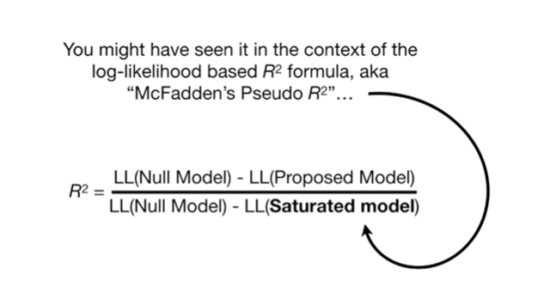

You might have seen it in the context of the log likelihood based R squared formula aka McFadden's pseudo R squared

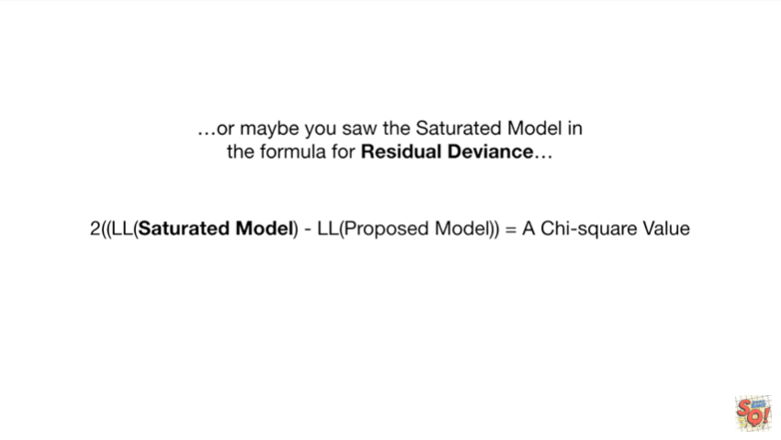

or maybe you saw the saturated model in the formula for residual deviance



or maybe you're just here for the song.

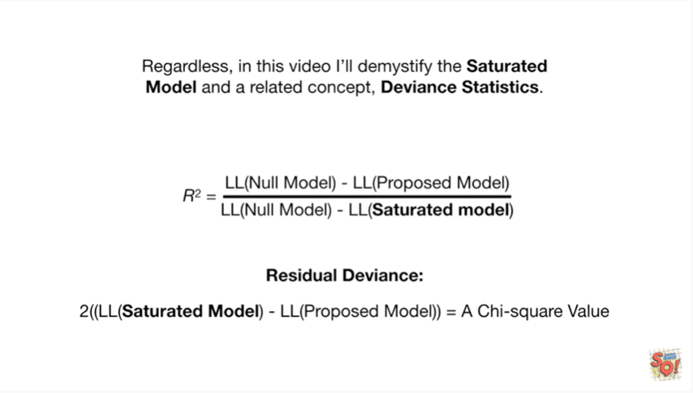

Regardless in this video I'll demystify the saturated model and a related concept deviant statistics.

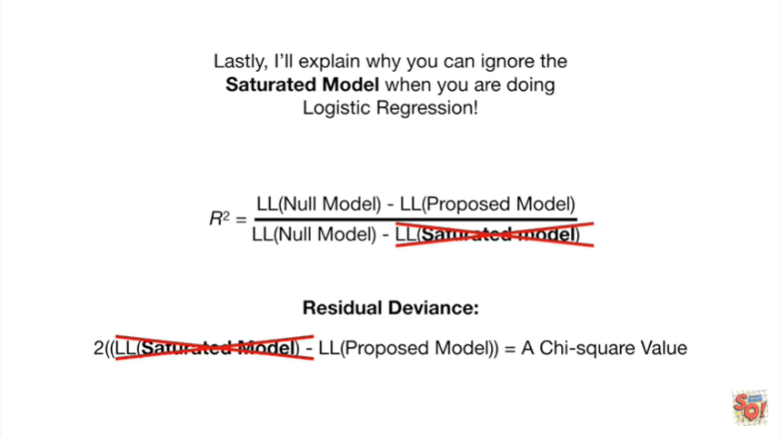

Lastly I'll explain why you can ignore the saturated model when you're doing logistic regression.

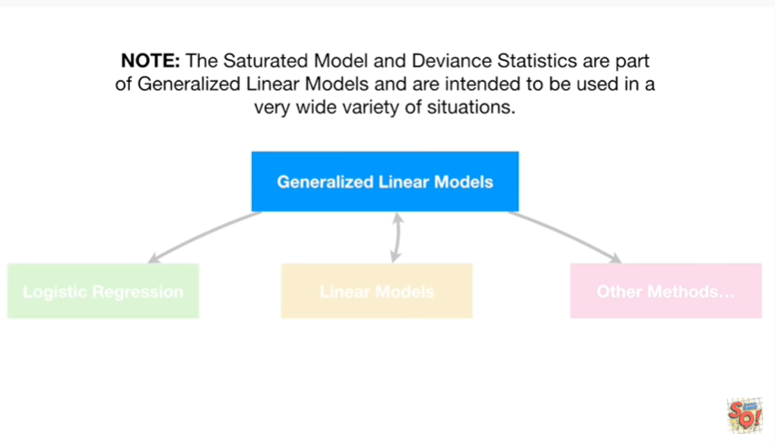

Note the saturated model and deviance statistics are part of generalized linear models and are intended to be used in a wide variety of situations.

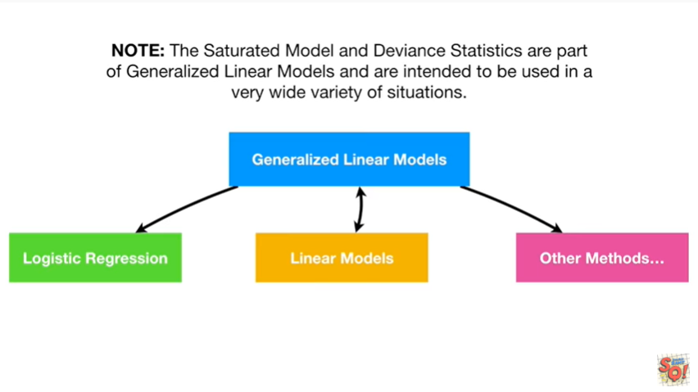

including but not limited to logistic regression, linear models and other methods.

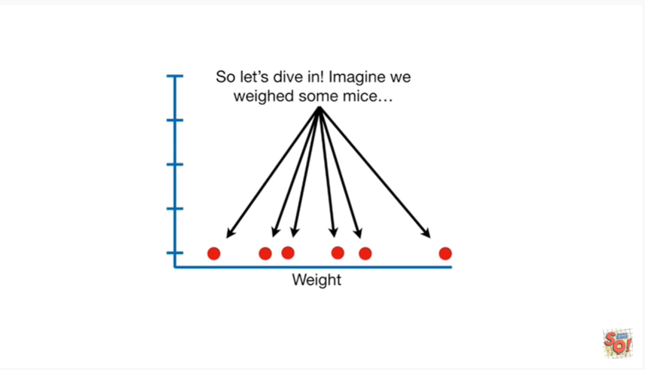

So let's dive in imagine we weighed some mice.

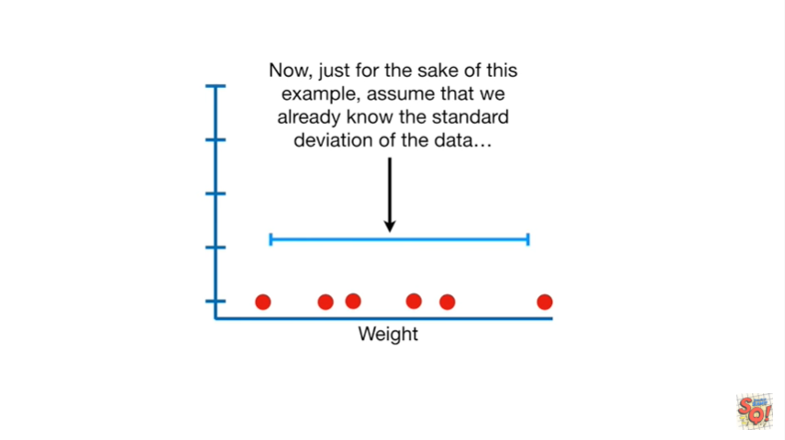

Now just for the sake of this example assume that we already know the standard deviation of the data

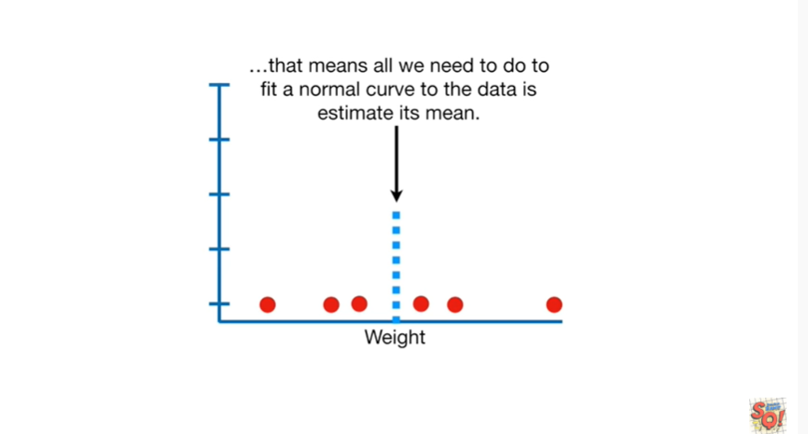

that means all we need to do to fit a normal curve to the data is estimate its mean.

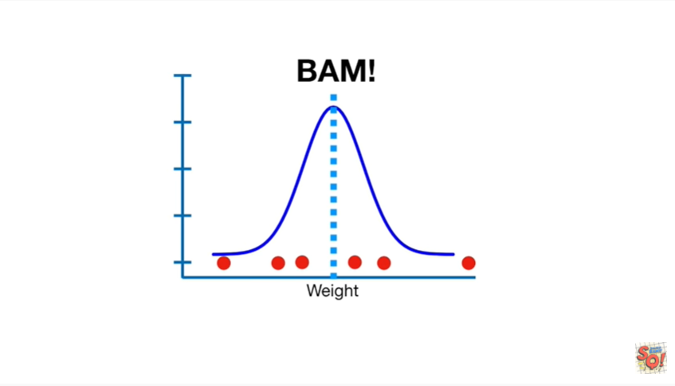

BAM !!!

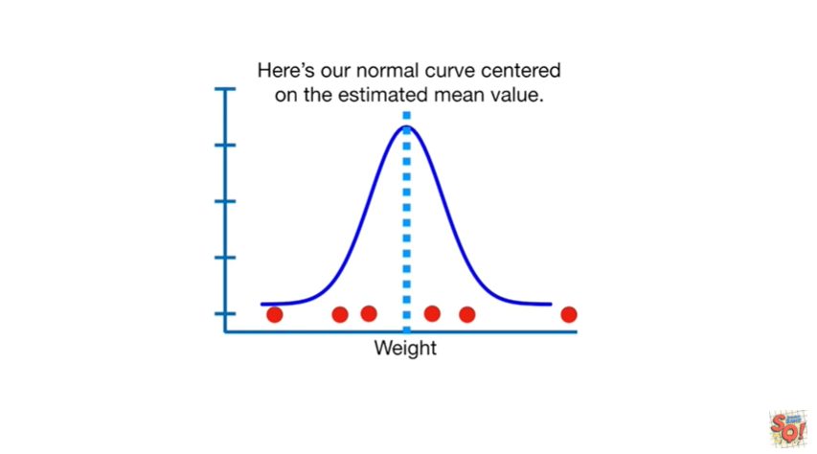

Here's our normal curve centered on the estimated mean value.

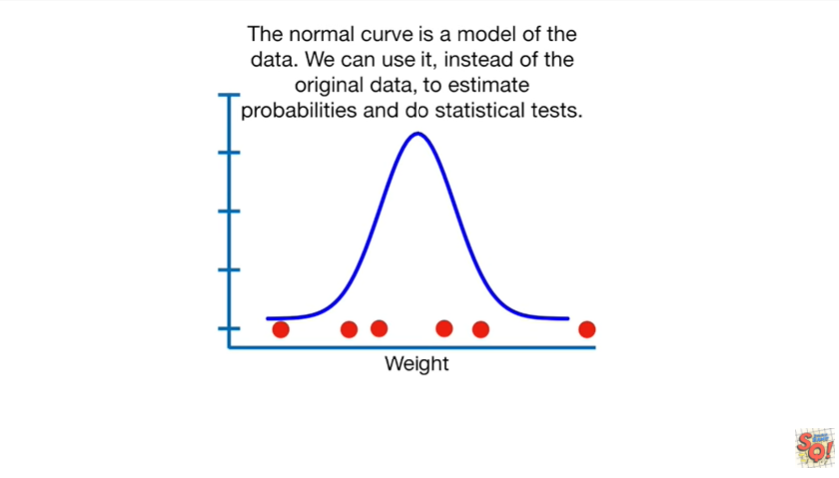

The normal curve is a model of the data we can use it instead of the original data to estimate probabilities and do statistical tests.

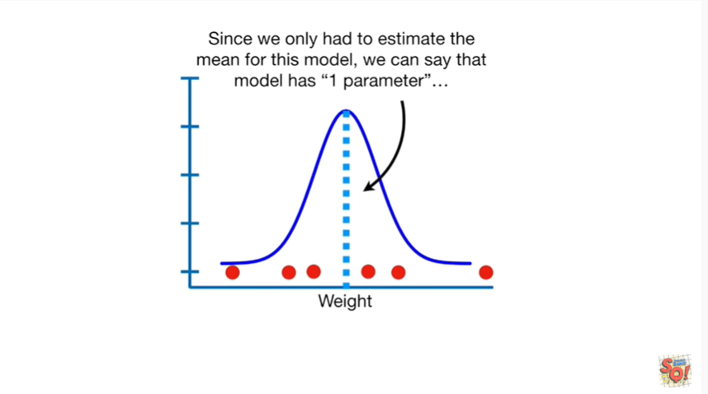

Since we only had to estimate the mean for this model we can say that the model has one parameter.

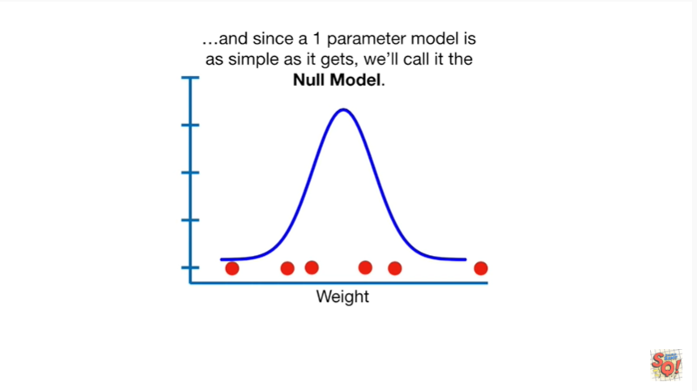

And since a one parameter model is as simple as it gets we'll call it the null model.

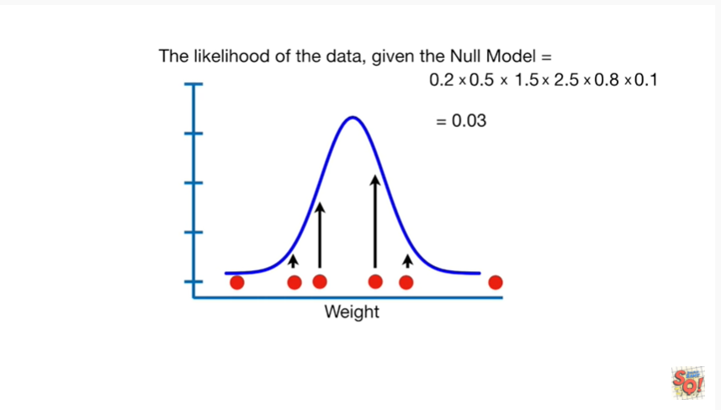

The likelihood of the data given the null model equals 0.03.

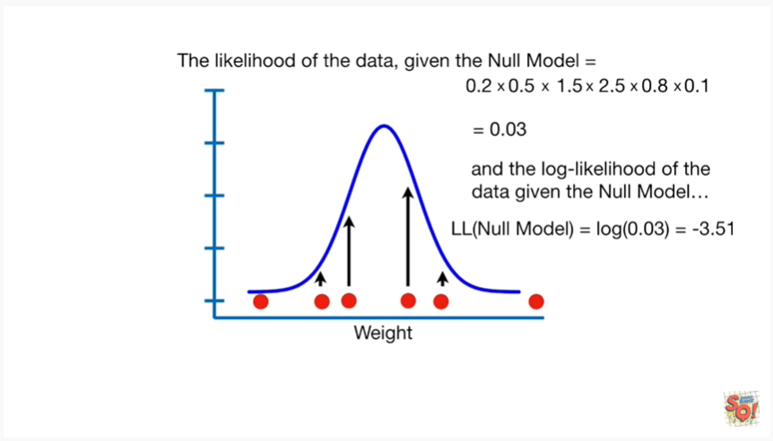

In the log likelihood of the data given the null model equals the log of 0.03, which equals negative 3.5 1.

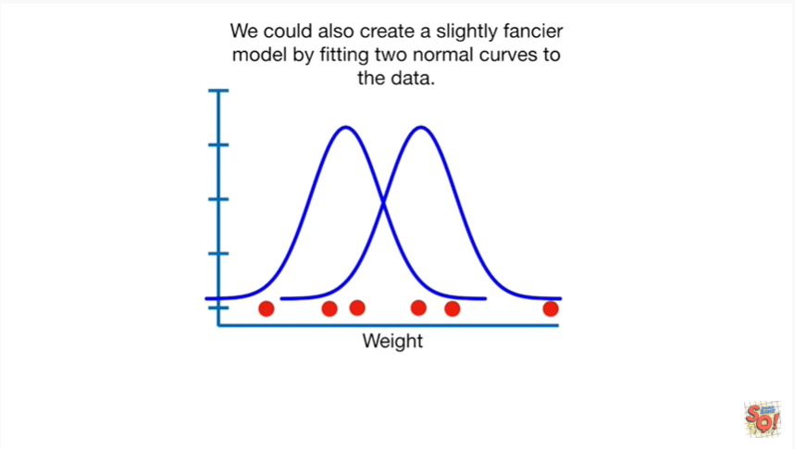

We could also create a slightly fancier model by fitting two normal curves to the data.

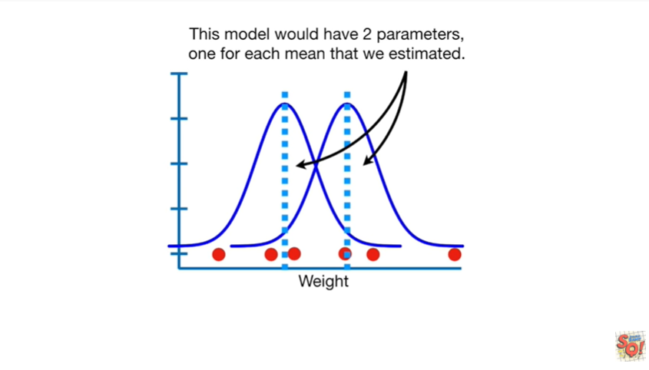

This model would have two parameters one for each mean that we estimated.

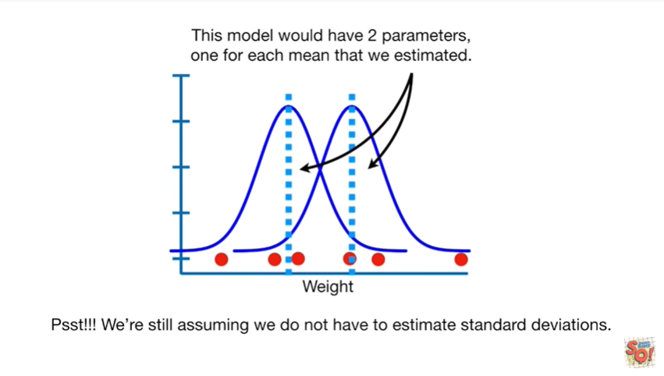

Pssst !!! we're still assuming we do not have to estimate standard deviations.

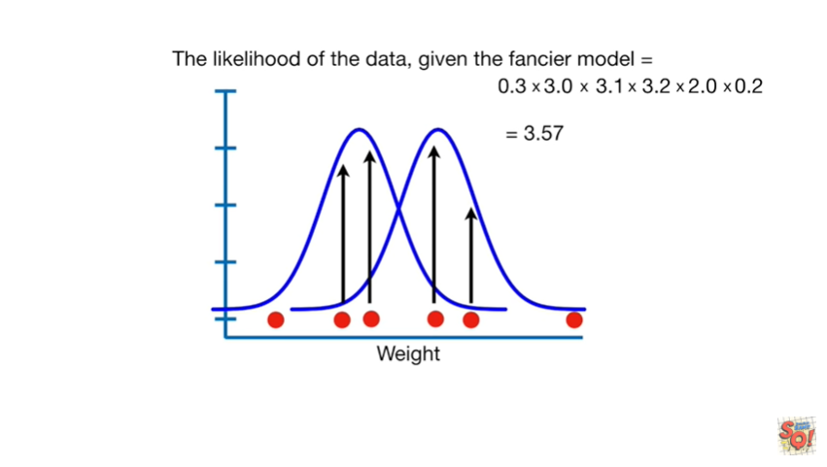

The likelihood of the data given the fancier model equals three point five seven.

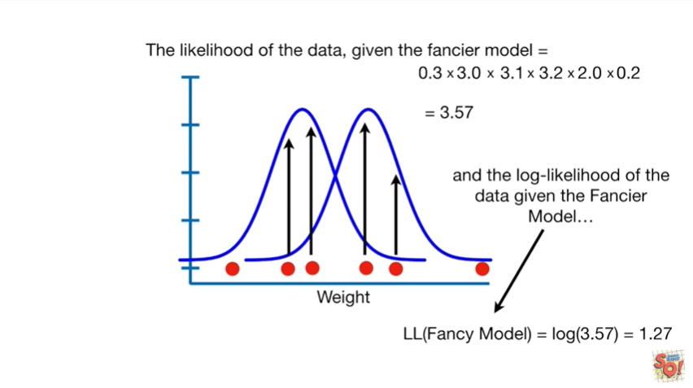

And the log likelihood of the data given the fancier model equals the log of three point five seven, which equals one point two seven.

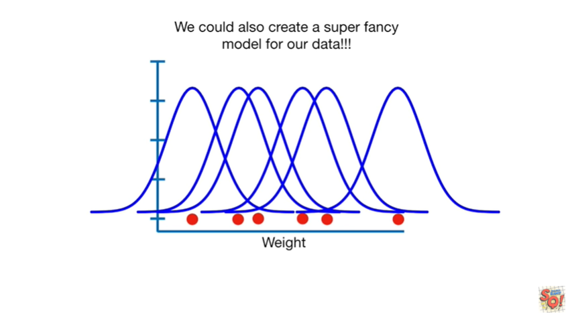

We could also create a super fancy model for our data.

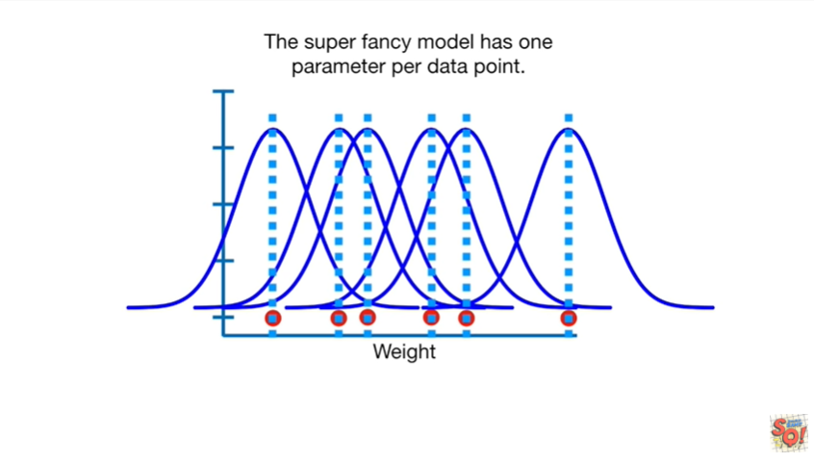

The super fancy model has one parameter per data point.

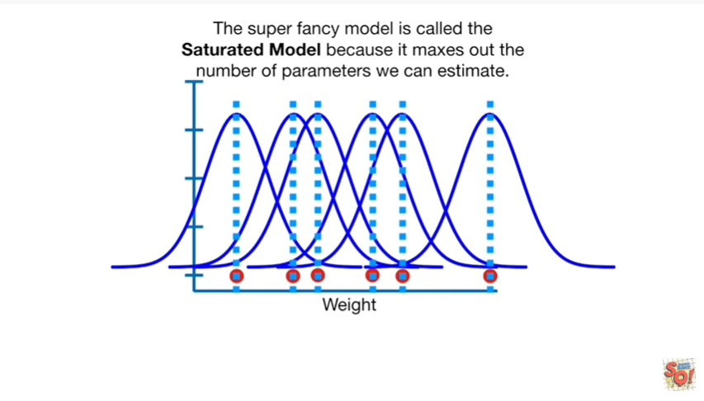

The super fancy model is called the saturated model because it maxes out the number of parameters we can estimate.

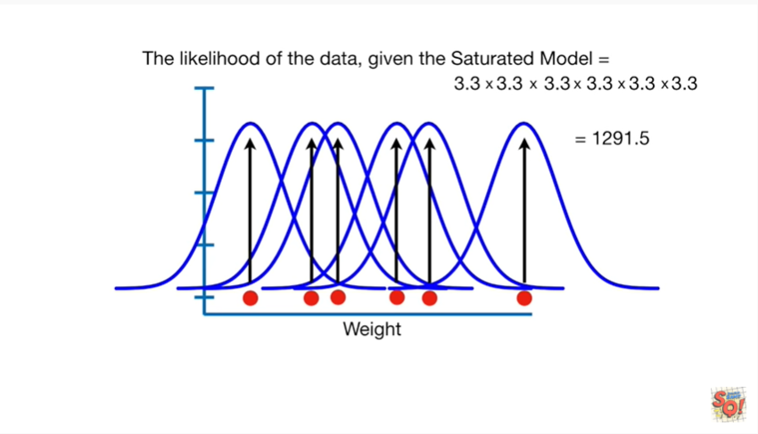

The likelihood of the data given the saturated model equals 1291 point five.

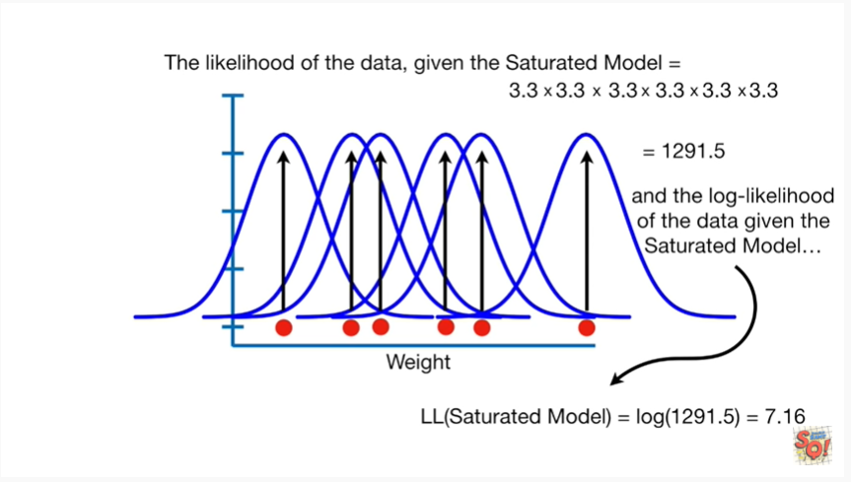

And the log likelihood of the data given the saturated model is the log of 1291 point five, which equals seven point one six.



So far we've looked at the likelihood of the data using three different models.

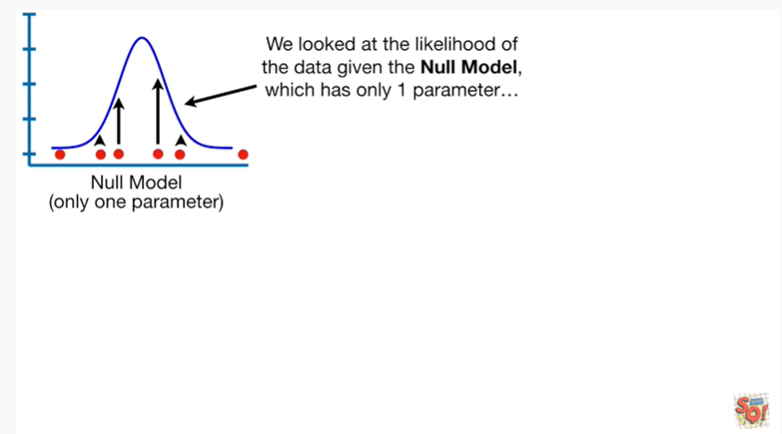

We looked at the likelihood of the data given the null model which has only one parameter.

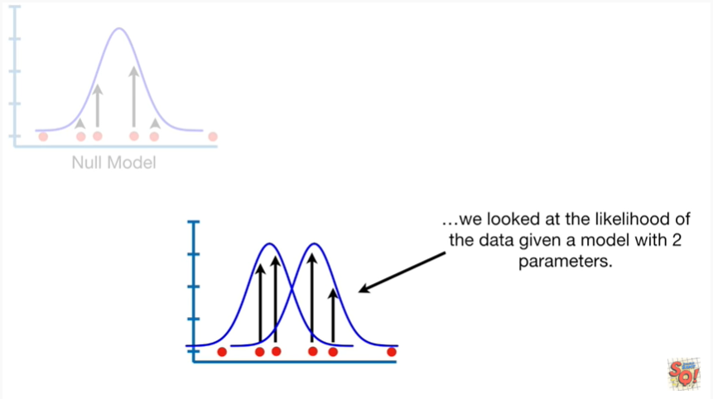

We looked at the likelihood of the data given a model with two parameters.

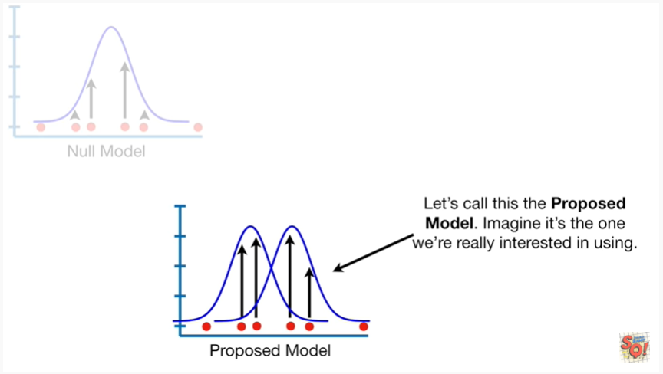

Let's call this the proposed model.

Imagine it's the one were really interested in using.

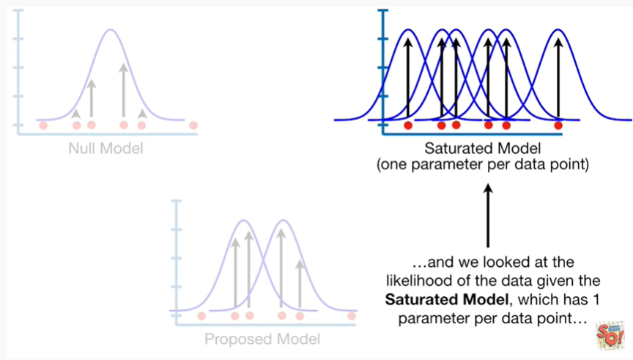

And we looked at the likelihood of the data given the saturated model which has one parameter per data point.

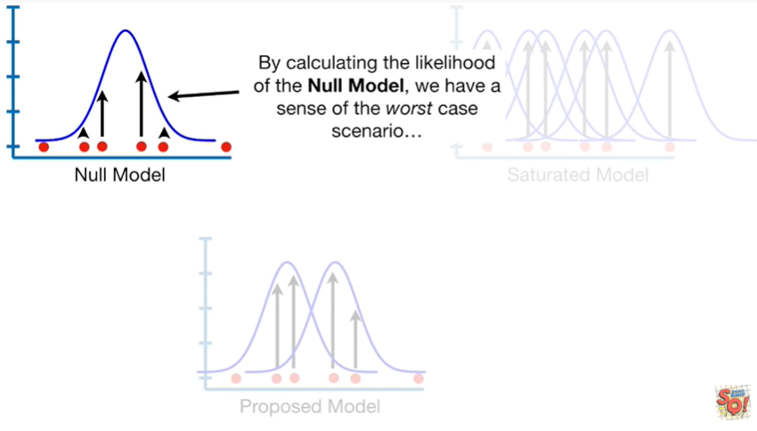

By calculating the likelihood of the null model we have a sense of the worst case scenario.

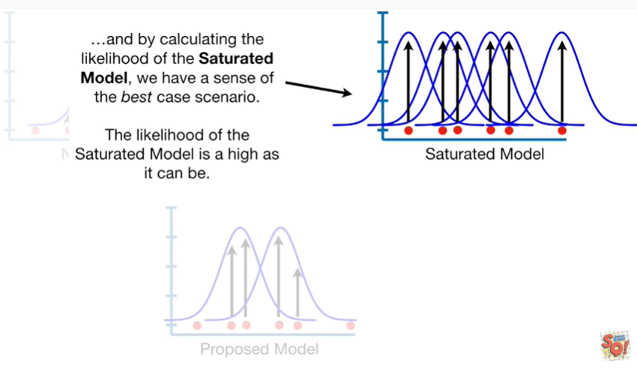

And by calculating the likelihood of the saturated model we have a sense of the best-case scenario.

The likelihood of the saturated model is as high as it can be.

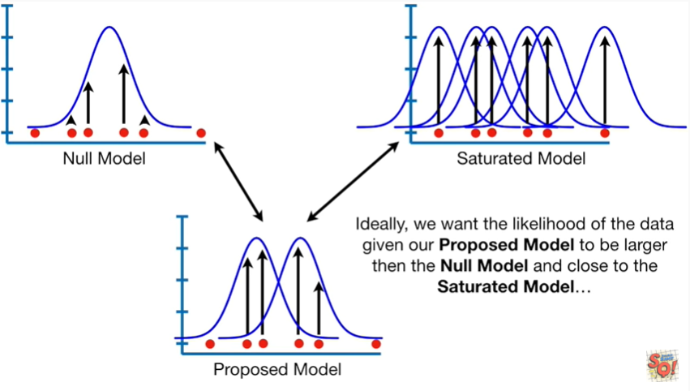

Ideally we want the likelihood of the data given our proposed model to be larger than the null model and close to the saturated model.

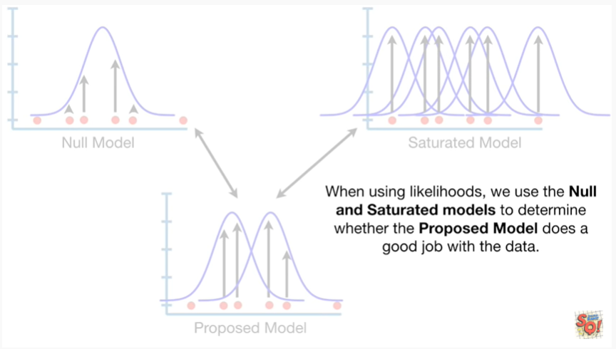

When using likelihoods we use the null and saturated models to determine whether the proposed model does a good job with the data.

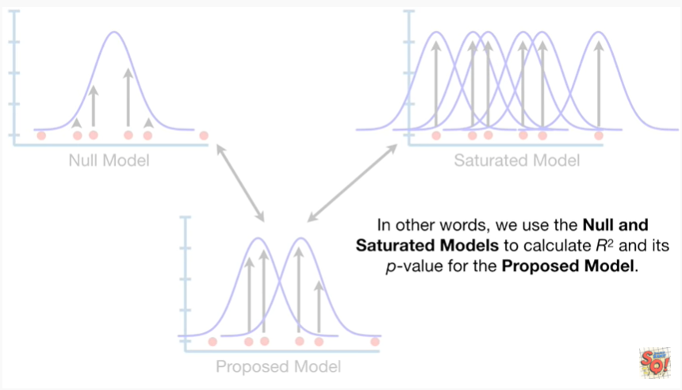

In other words we use the null and saturated models to calculate R squared and its p-value for the proposed model.

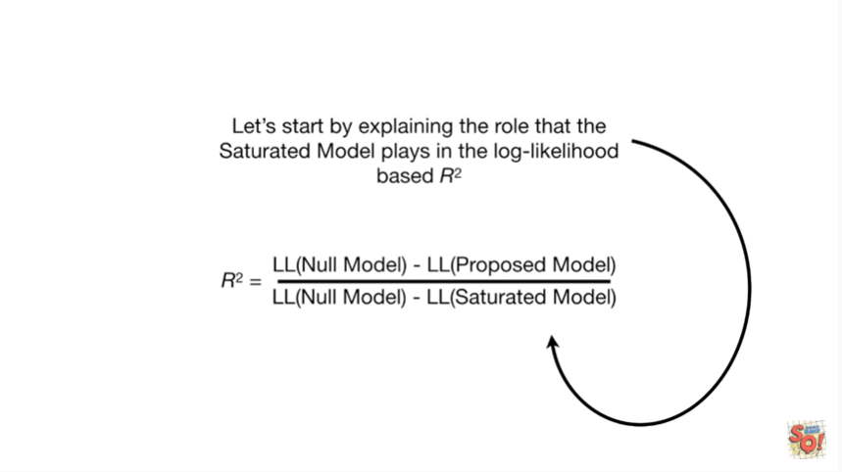

Let's start by explaining the role that the saturated model plays in the log-likelihood paste r-squared.

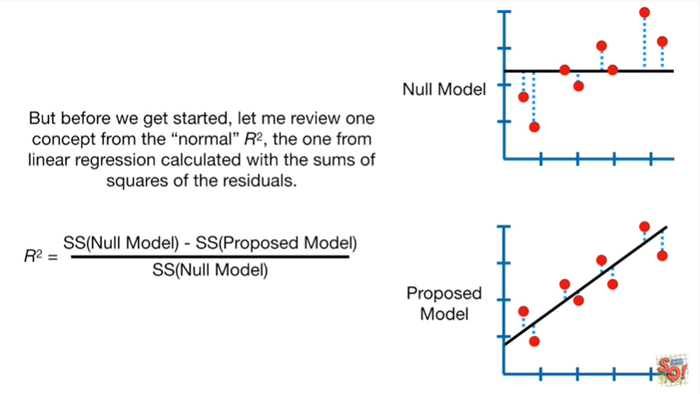

But before we get started let me review one concept from the normal r-squared, the one from linear regression calculated with the sums of squares of the residuals.

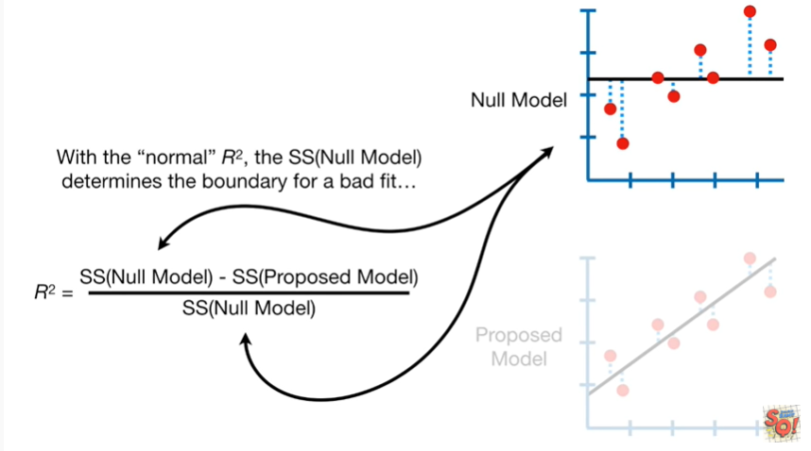

With the normal r-squared this sums of squares for the null model determines the boundary for a bad fit.

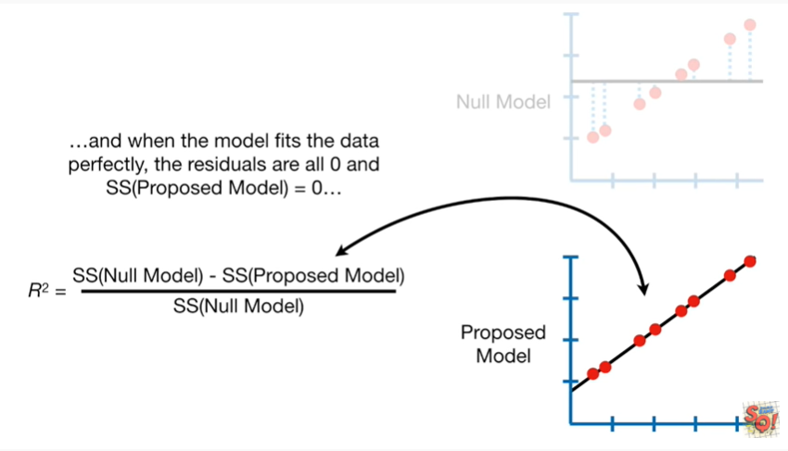

And when the model fits the data perfectly the residuals are all 0 in the sums of squares for the proposed model equals 0.

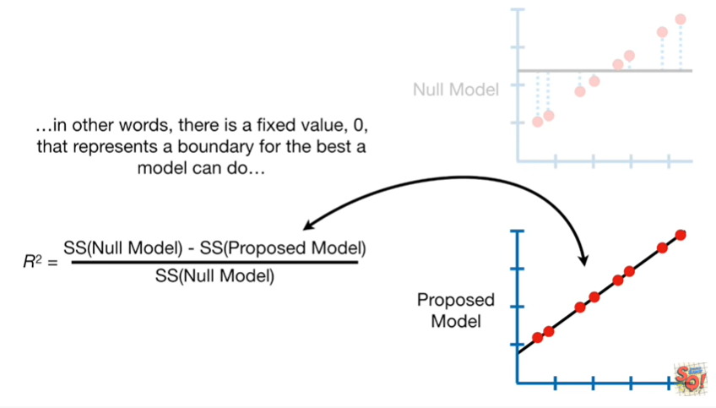

In other words there is a fixed value 0 that represents a boundary for the best a model can do

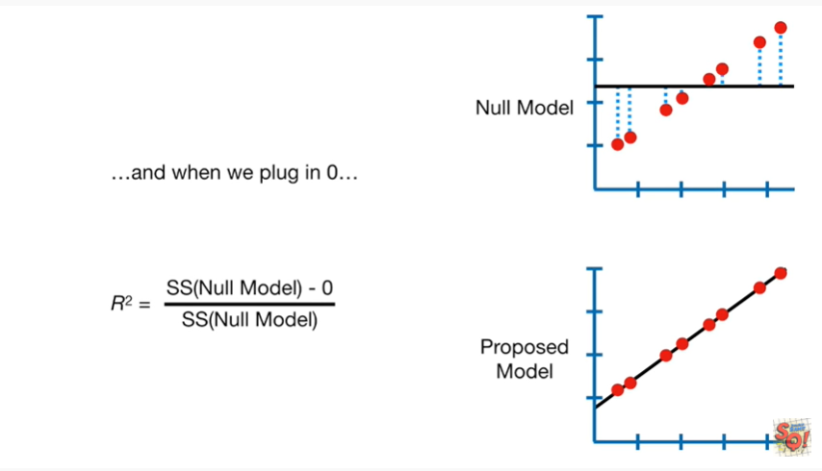

and when we plug in 0

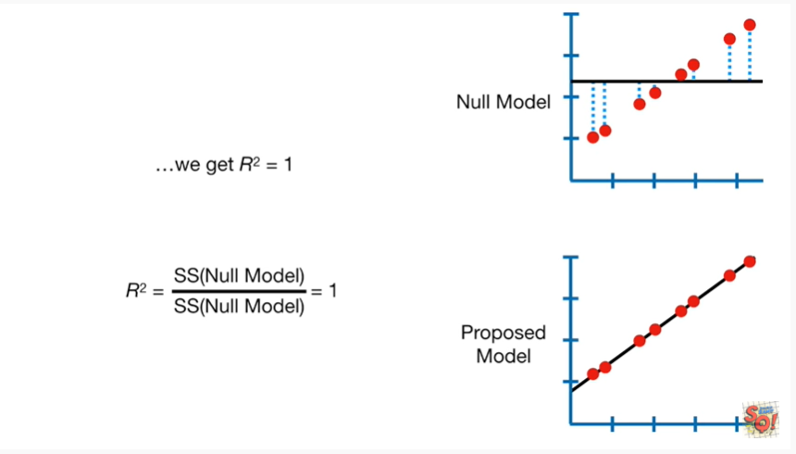

we get R squared equals 1.

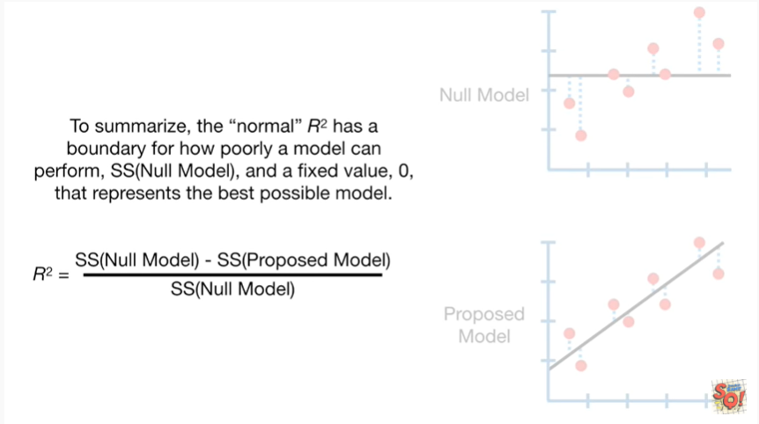

To summarize the normal r-squared has a boundary for how poorly a model can perform, the sums of squares for the null model and a fixed value zero that represents the best possible model.

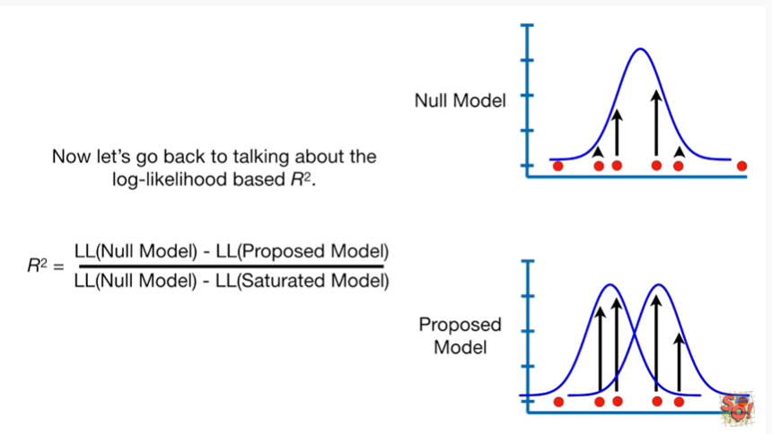

Now let's go back to talking about the log likelihood based R squared.

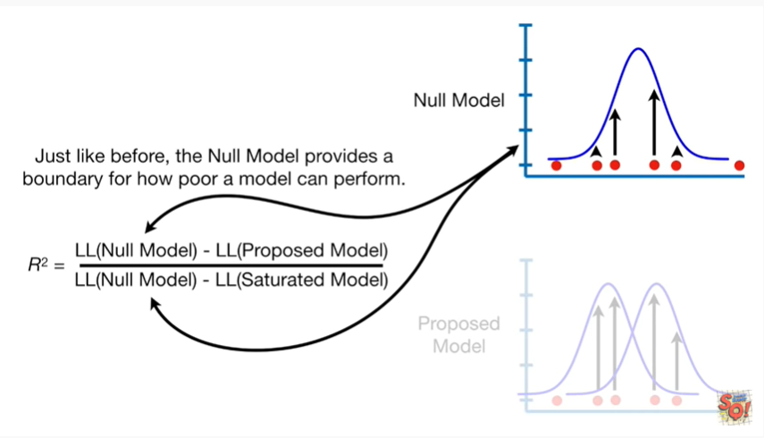

Just like before the null model provides a boundary for how poor a model can perform.

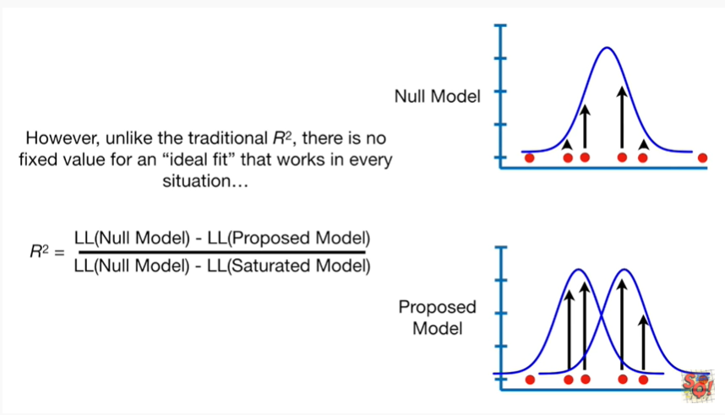

However unlike the traditional R squared there is no fixed value for an ideal fit that works in every situation

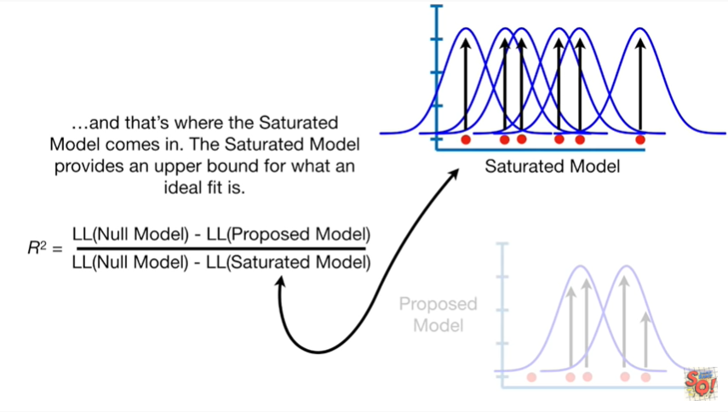

and that's where the saturated model comes in.

The saturated model provides an upper bound for what an ideal fit is.

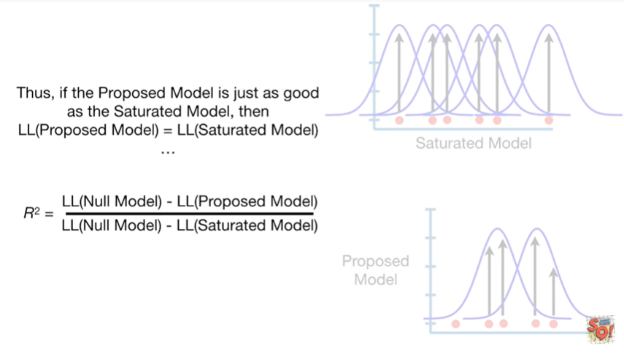

Thus if the proposed model is just as good as the saturated model then the log-likelihood of the proposed model will equal the log likelihood of the saturated model

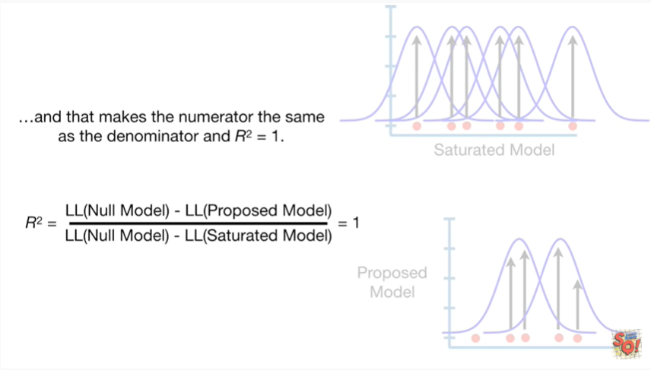

and that makes the numerator the same as the denominator and r-squared equals one.

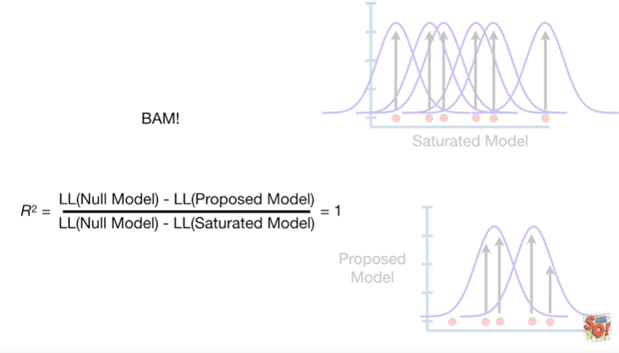

BAM !!!

But not a big BAM, just a little BAM.

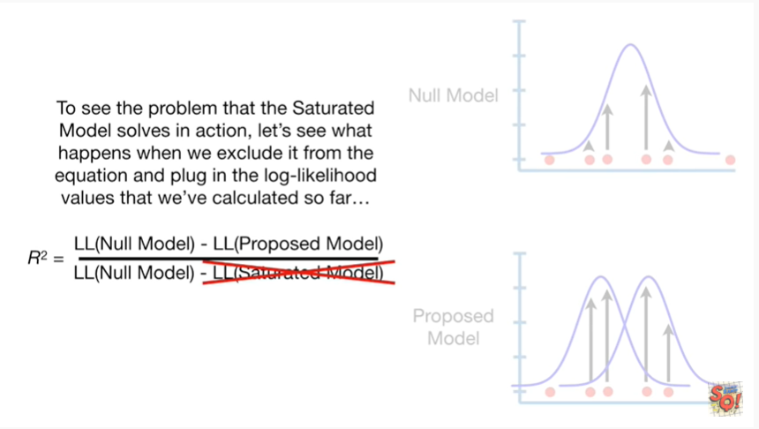

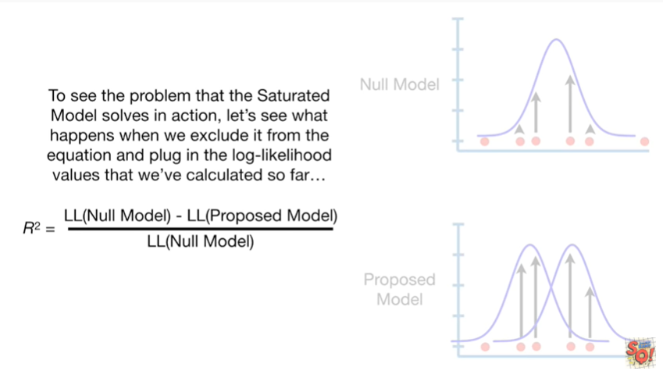

For now to see the problem that the saturated model solves in action, let's see what happens when we exclude it from the equation and plug in the log likelihood values that we've calculated so far.

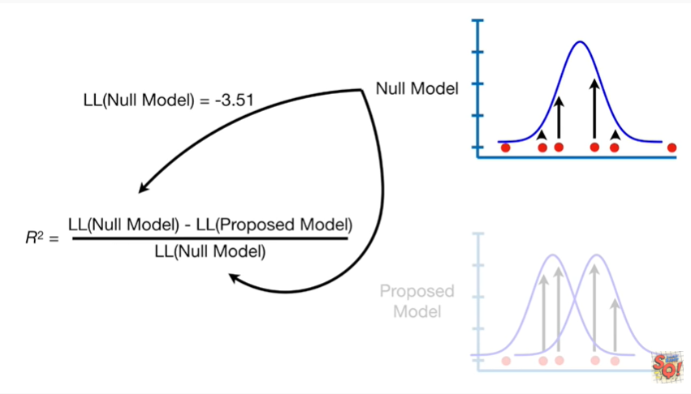

First we plug in the log likelihood for the null model

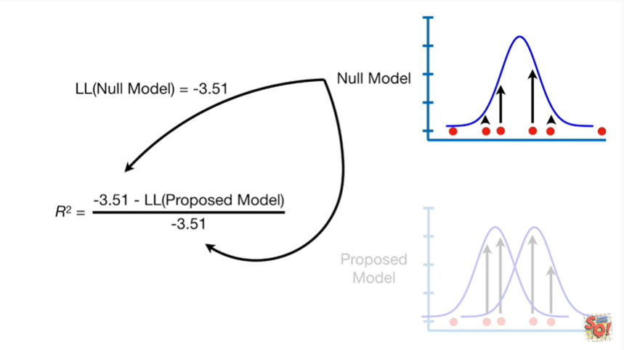

that's negative three point five one

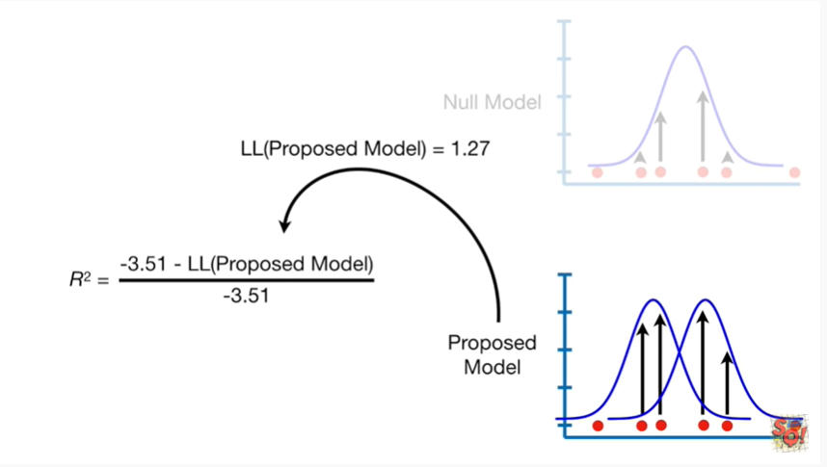

then we plug in the log likelihood for the proposed model

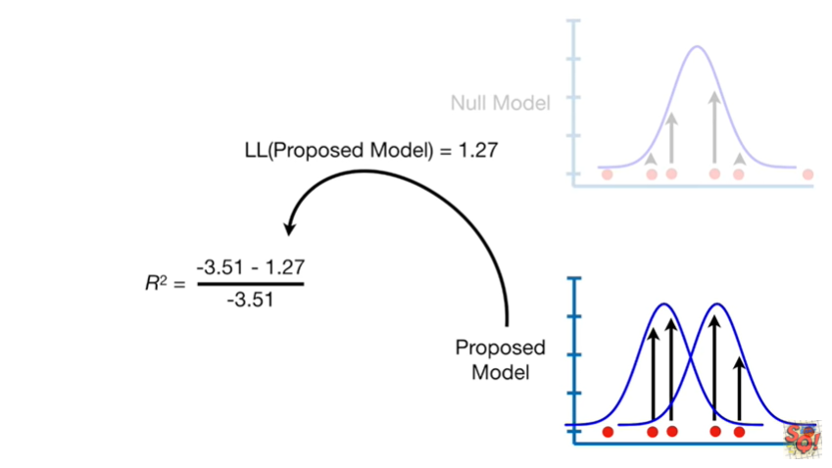

that equals one point two seven

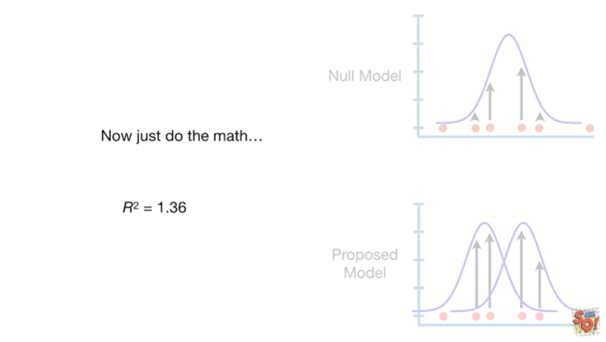

now just do the math.

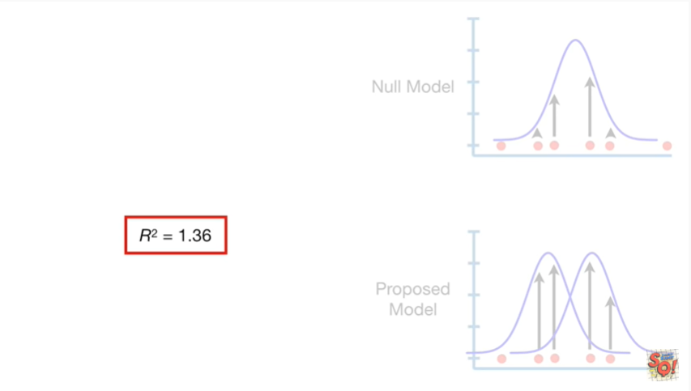

When we leave out the saturated model the r-squared equals one point three six.

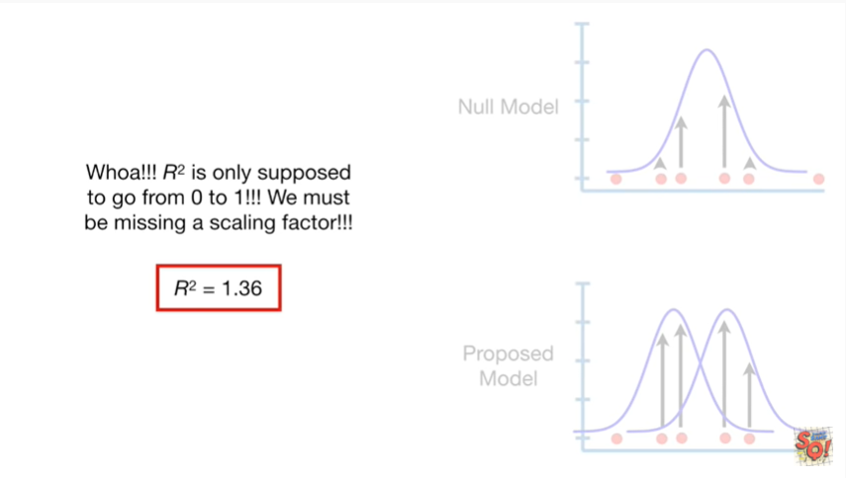

Whoa our squared is only supposed to go from zero to one, we must be missing a scaling factor.

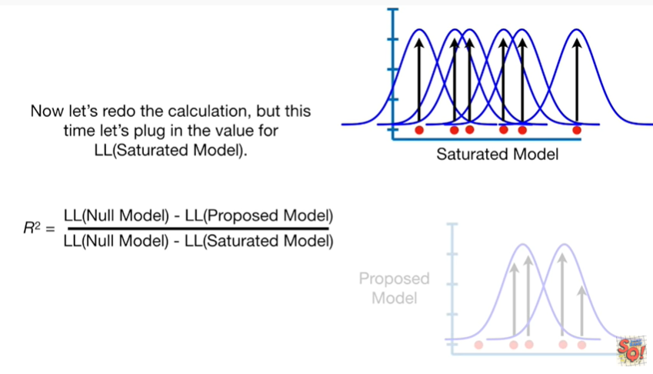 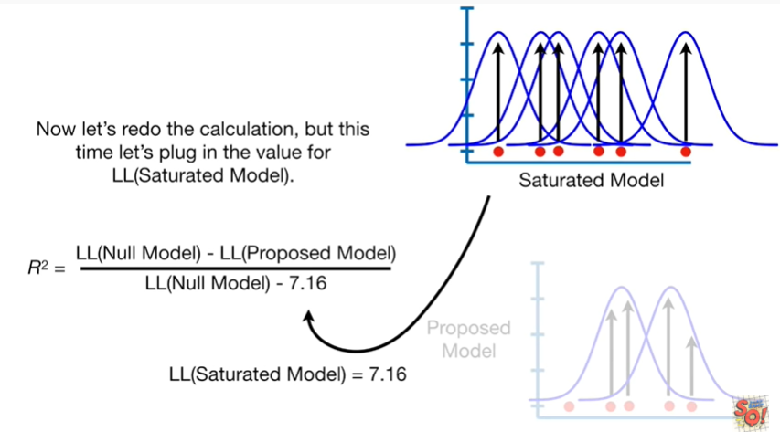

Now let's redo the calculation but this time let's plug in the value for the log likelihood of the saturated model.

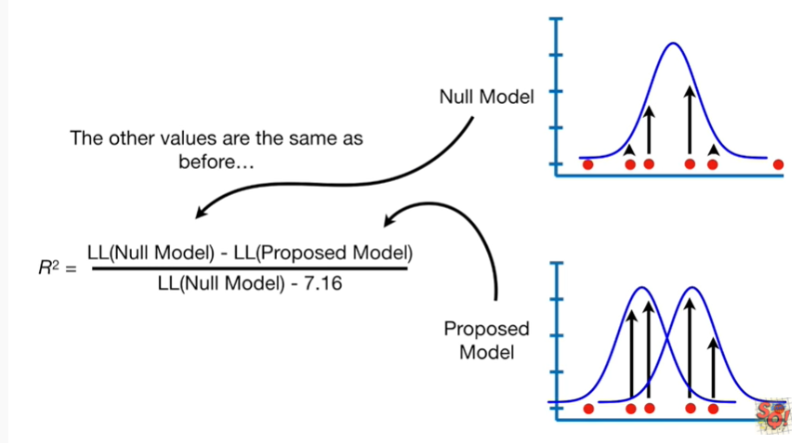

The other values are the same as before

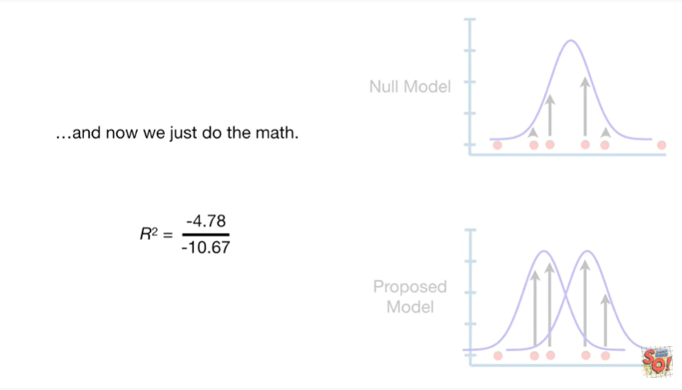

and now we just do the math this time

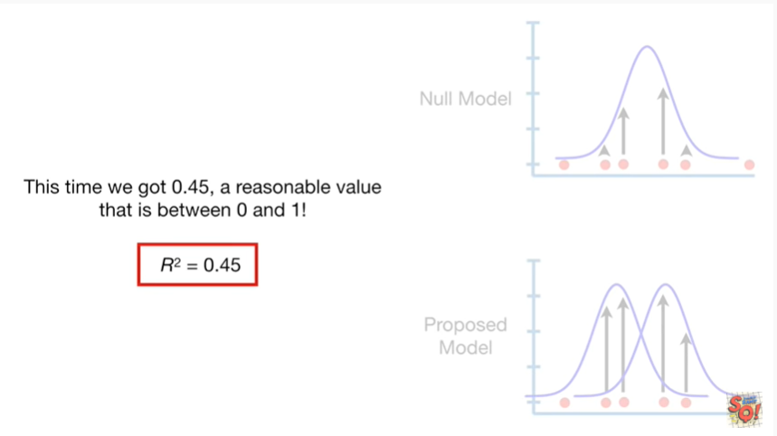

we got 0.45 a reasonable value that is between 0 & 1.

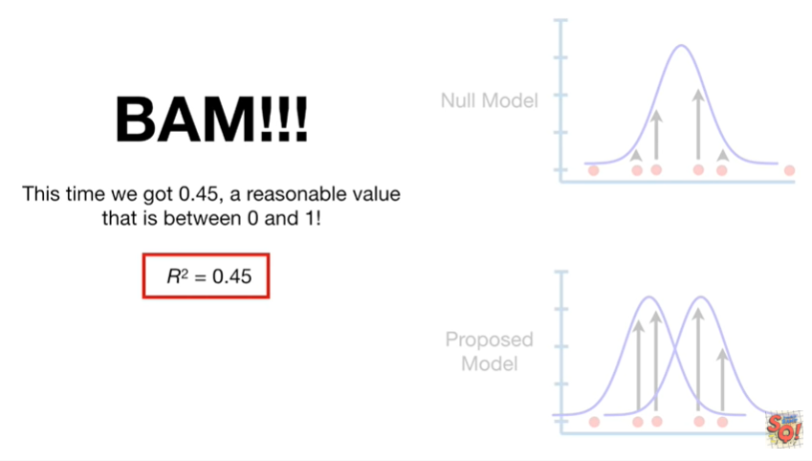

This deserves a big Bam.

Bam !!!

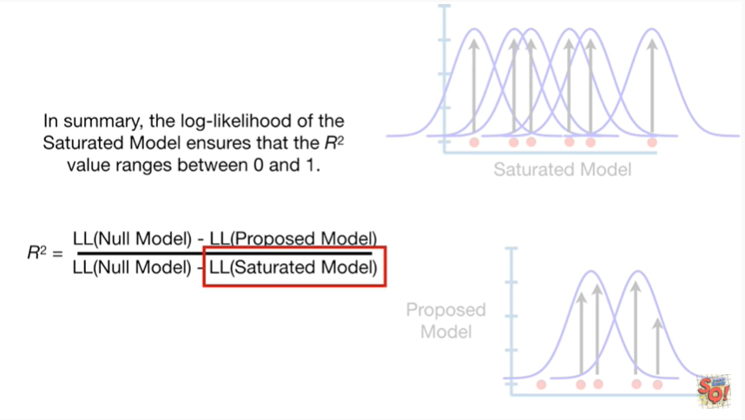

In summary the log-likelihood of the saturated model ensures that the r-squared value ranges between zero and one.

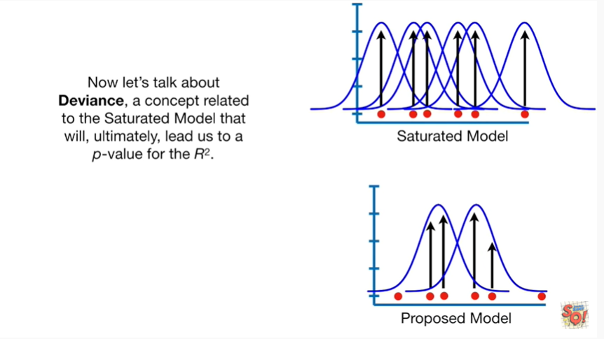

Now let's talk about deviance, a concept related to the saturated model that will ultimately lead us to a p-value for the r-squared.

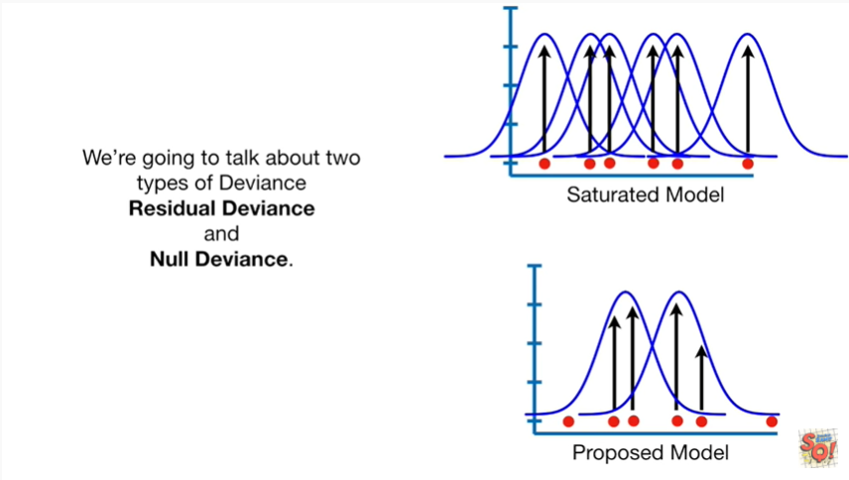

We're going to talk about two types of deviants residual deviance and null deviance.

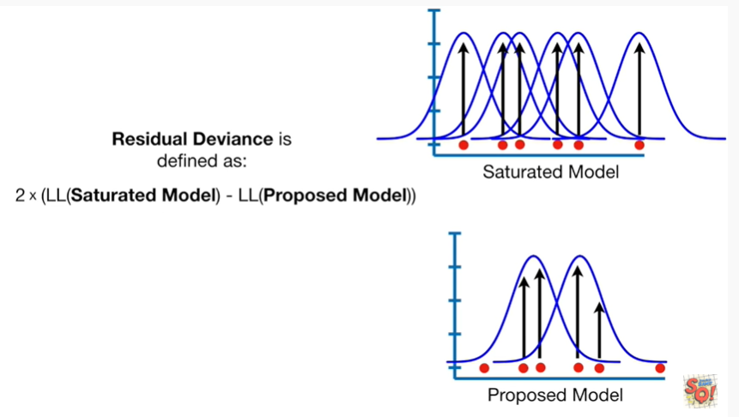

Residual deviance is defined as two times the difference between the log-likelihood of the saturated model and the log-likelihood of the proposed model.

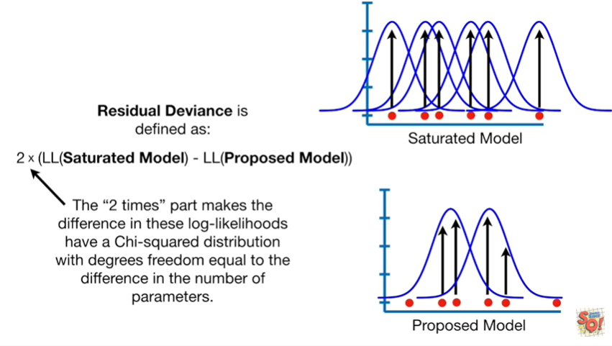

The two times part makes the difference in these log likelihoods have a chi-squared distribution with degrees freedom equal to the difference in the number of parameters.

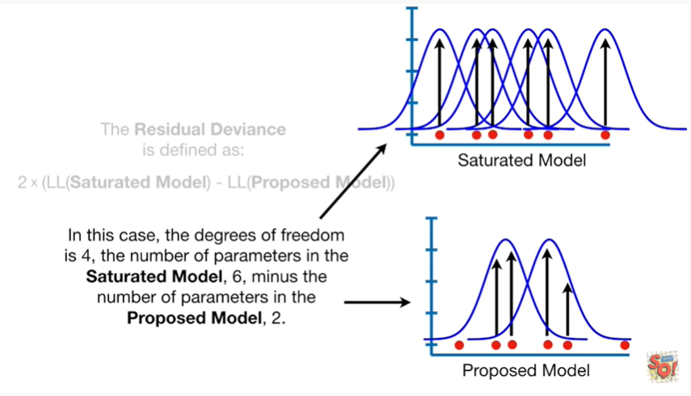

In this case the degrees of freedom is for the number of parameters in the saturated model 6 - the number of parameters in the proposed model – 2.

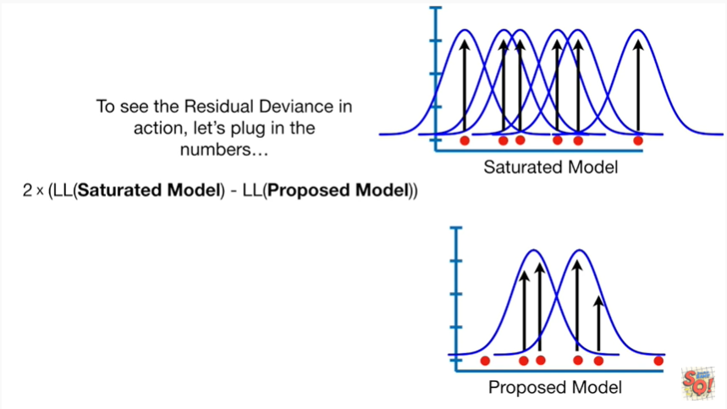

To see the residual deviance in action let's plug in the numbers

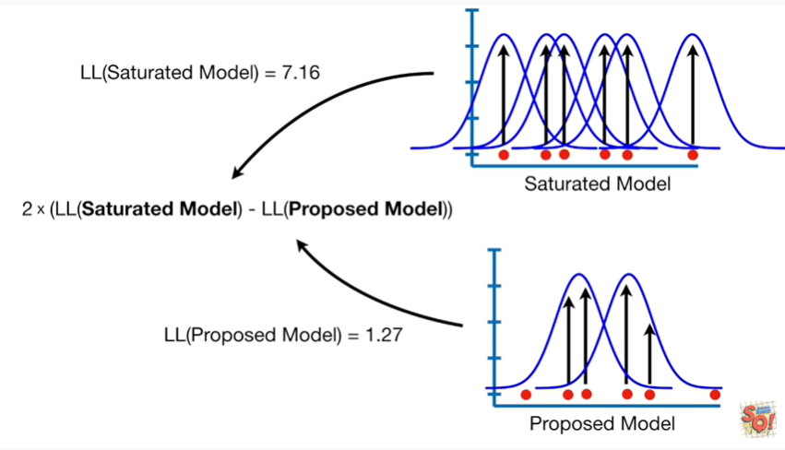

boo-boo-boo-boo-boo PPP boo

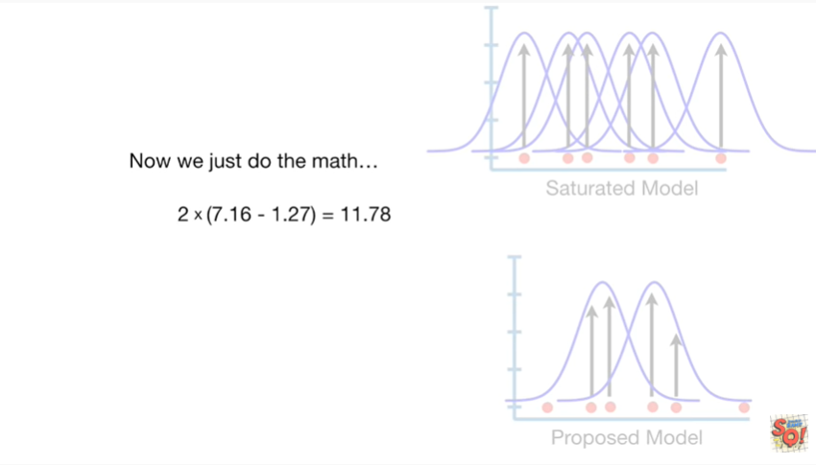

Now we just do the math and we get eleven point seven eight.

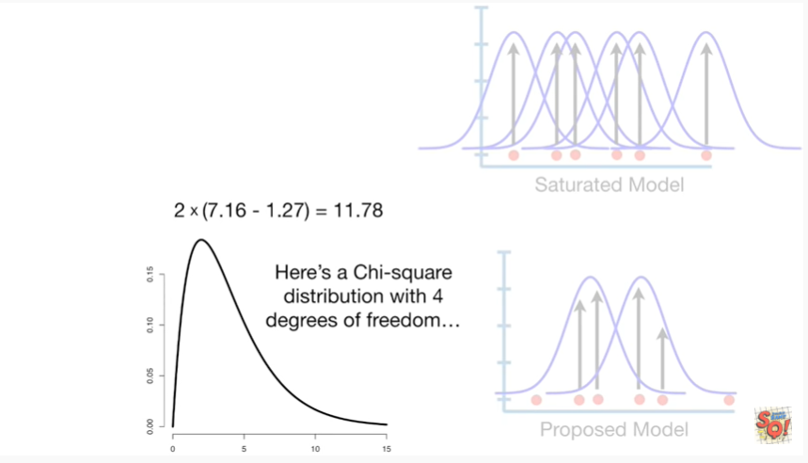

Here's a chi-square distribution with four degrees of freedom

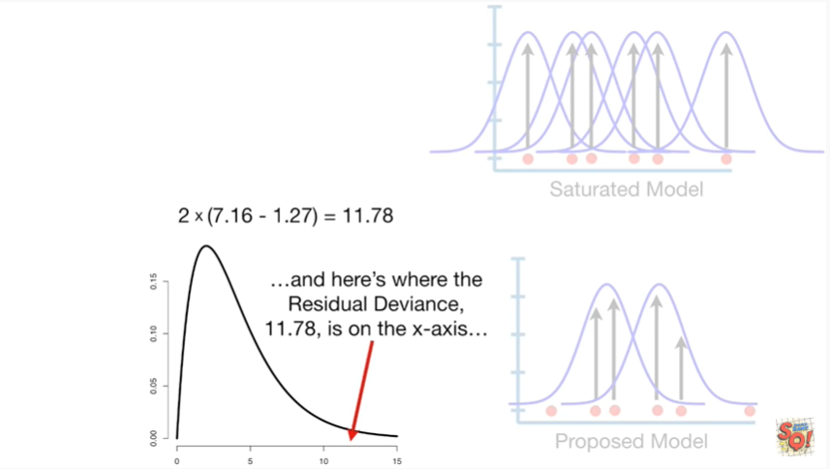

and here's where the residual deviance 11.7 8 is on the x-axis

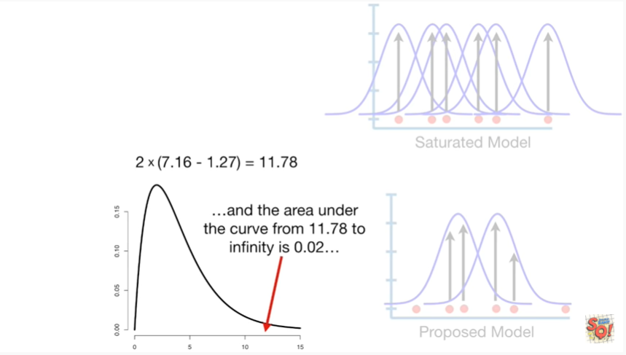

and the area under the curve from eleven point seven eight to infinity is zero point zero two

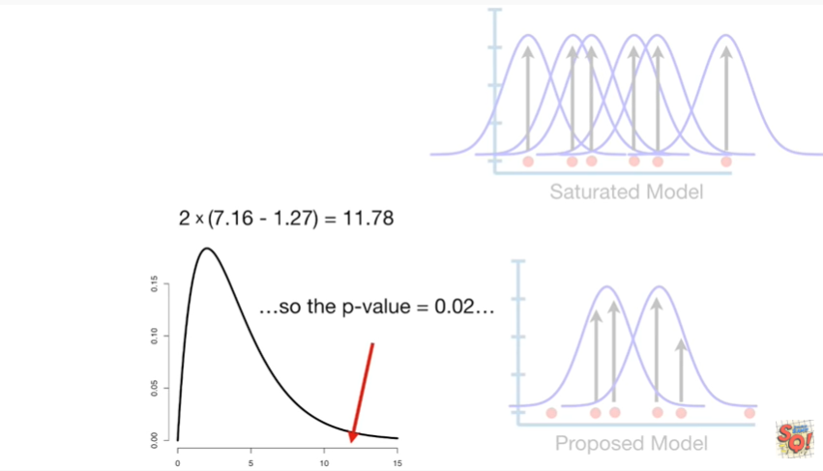

so the p value equals zero point zero two

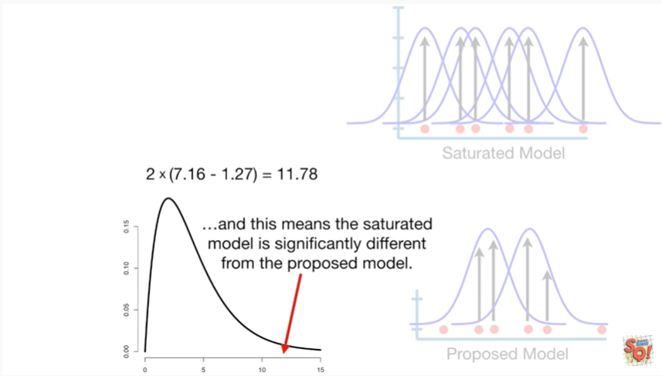

and this means that the saturated model is significantly different from the proposed model.

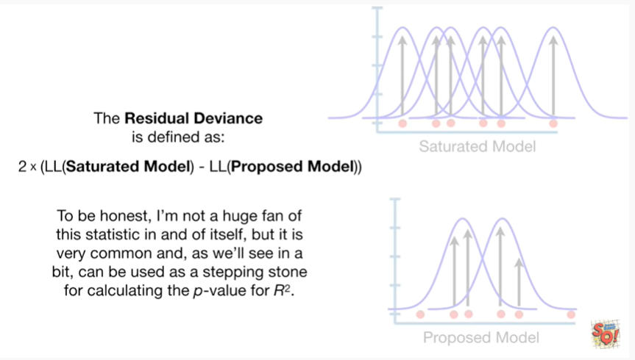

To be honest I'm not a huge fan of this statistic in and of itself, but it is very common and as we'll see in a bit, can be used as a stepping stone for calculating the p-value for r-squared.

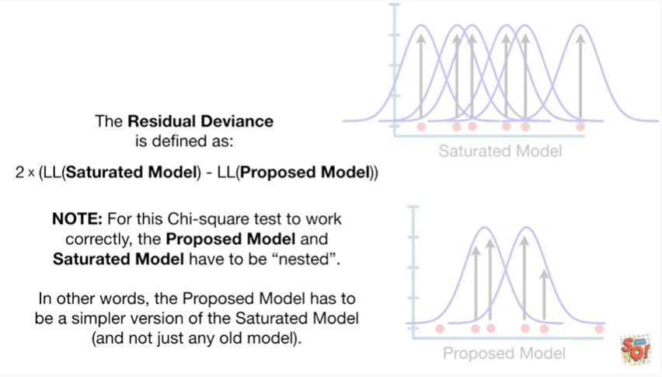

Note : for this chi-square test to work correctly the proposed model and the saturated model have to be nested.

In other words the proposed model has to be a simpler version of the saturated model and not just any old model.

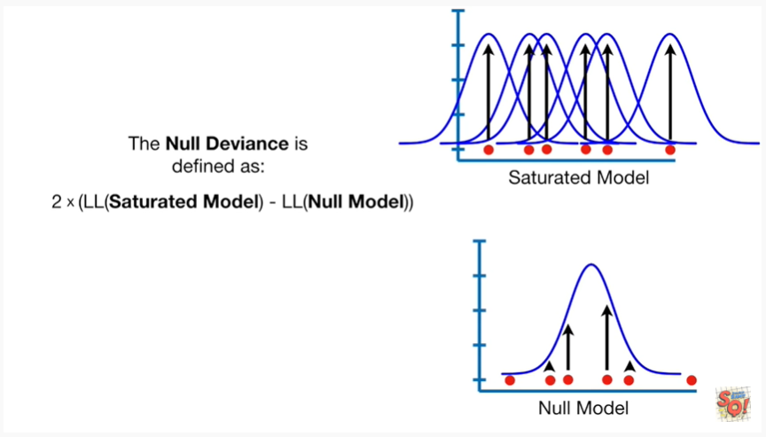

Now let's talk about the null deviance the null deviance is defined as two times the difference between the log-likelihood of the saturated model and the log-likelihood of the null model.

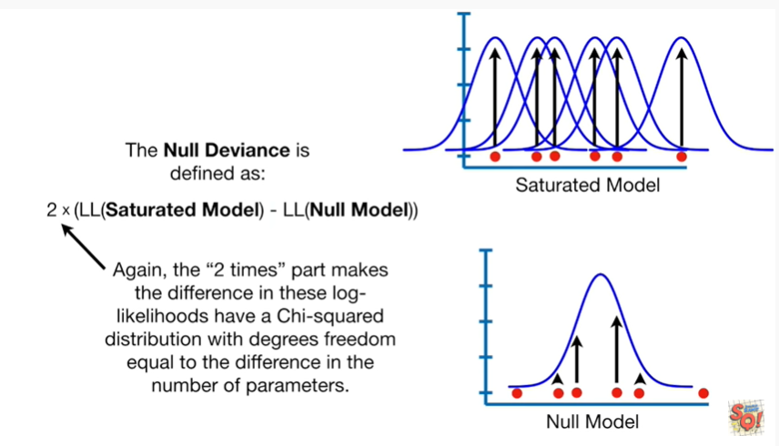

Again the two times part makes the difference in these log likelihoods have a chi-squared distribution with degrees freedom equal to the difference in the number of parameters.

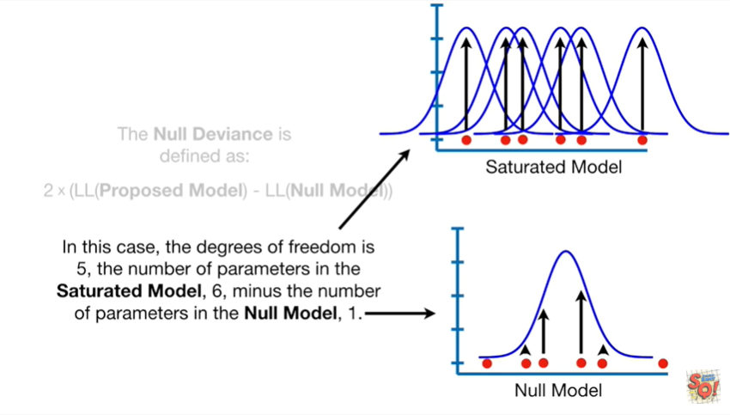

In this case the degrees of freedom is 5 the number of parameters in the saturated model 6 minus the number of parameters in the null model 1.

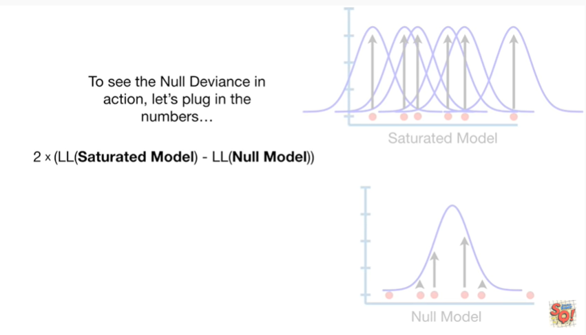

To see the null deviance in action let's plug in the numbers

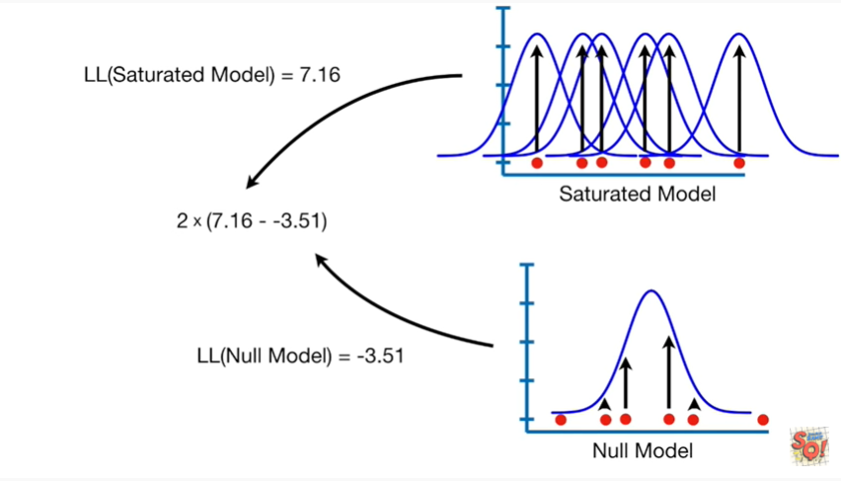

bbb-big boo boo boo boo boo boo

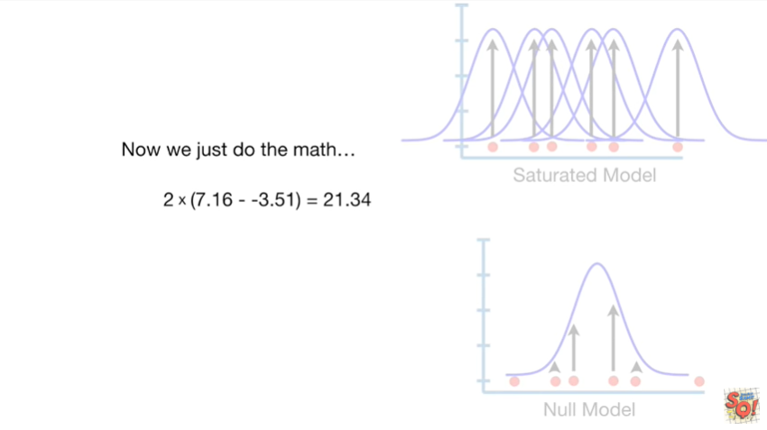

Now we just do the math and that gives us a value of 21 point 3 4.

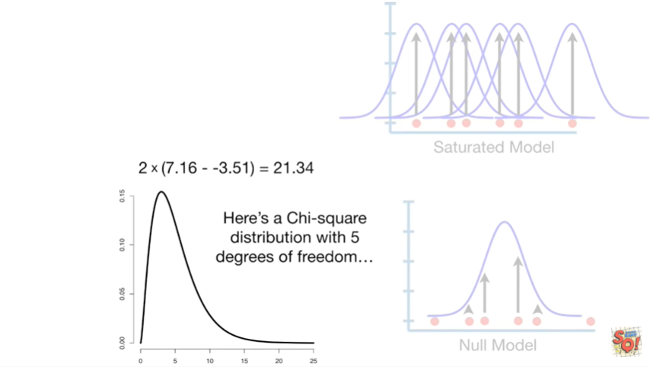

Here's a chi-square distribution with 5 degrees of freedom

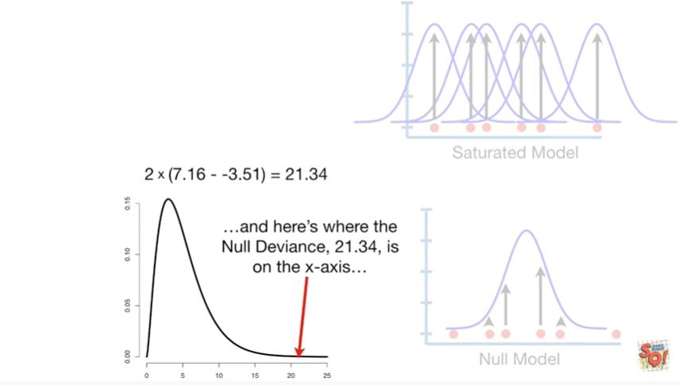

and here's where the null deviance 21 point 3 4 is on the x-axis

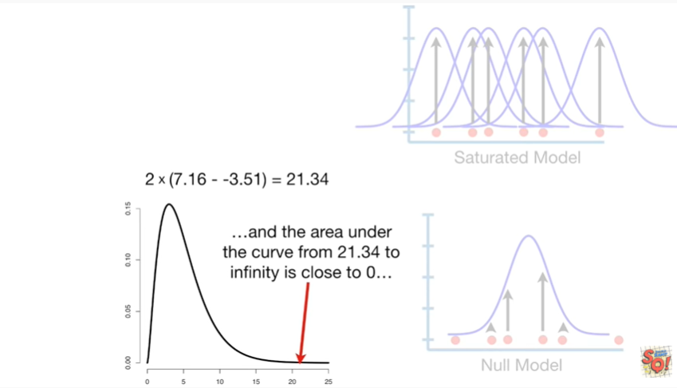

and the area under the curve from 21 point 3 4 to infinity is close to 0.

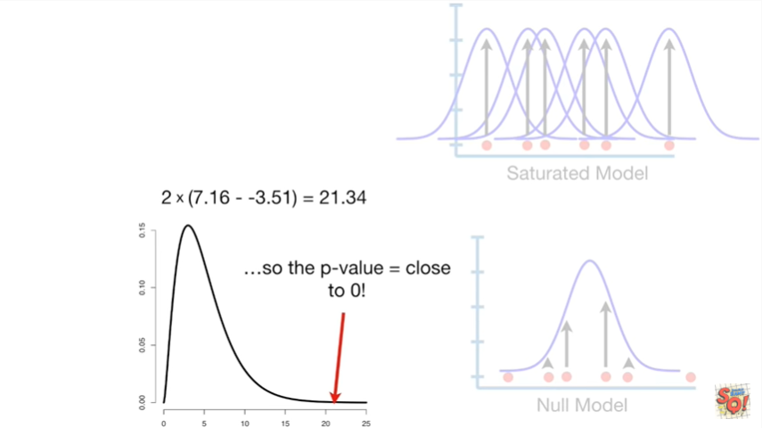

So the p value equals close to 0.

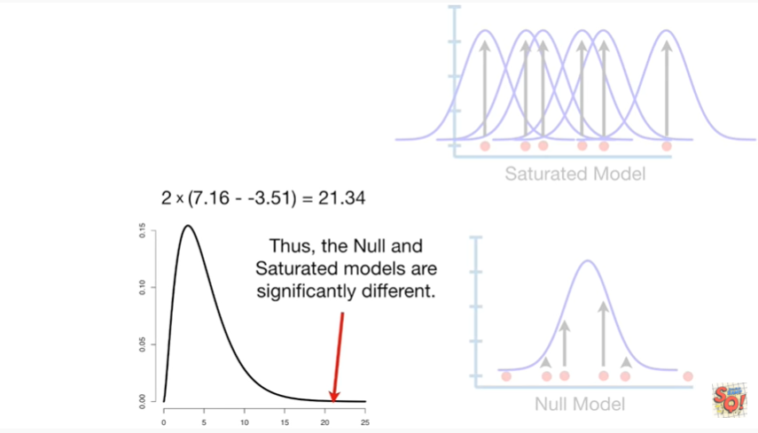

Thus the null unsaturated models are significantly different.

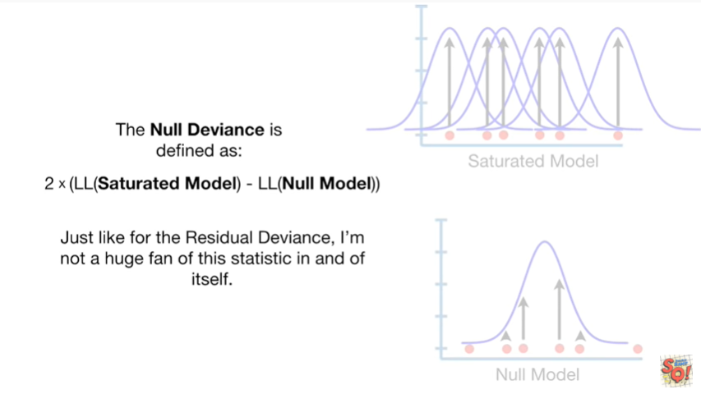

Just like for the residual deviance I'm not a huge fan of this statistic in and of itself.

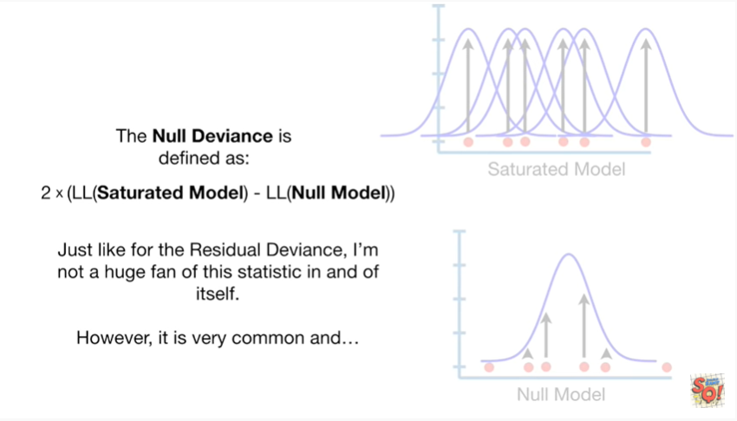

However it's very common and

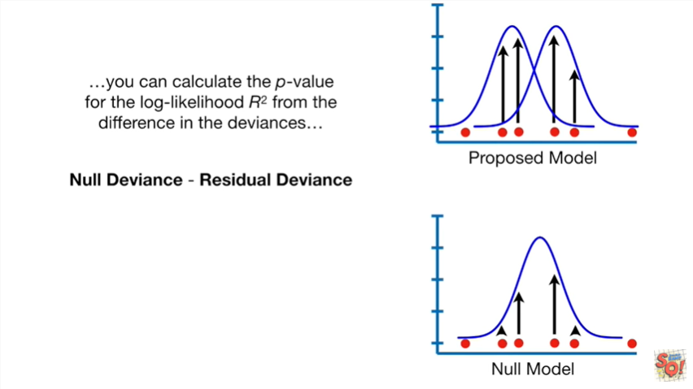

you can calculate the p-value for the log-likelihood r-squared from the difference in the deviances

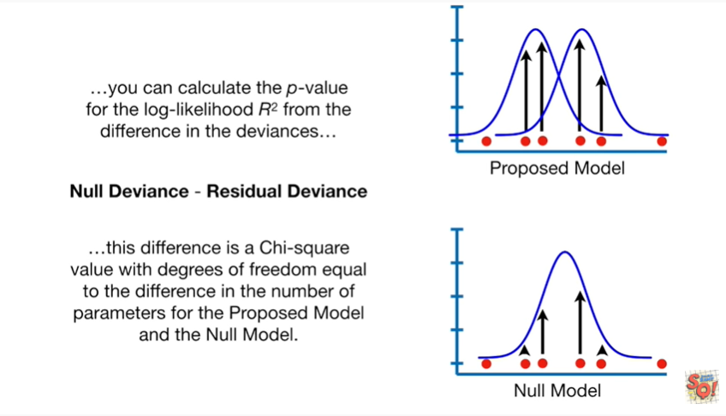

this difference is a chi-square value with degrees freedom equal to the difference in the number of parameters for the proposed model.

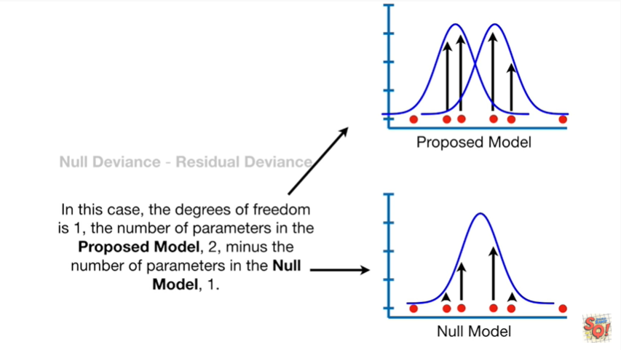

In the null model in this case the degrees of freedom is 1 the number of parameters in the proposed model 2 minus the number of parameters in the null model 1.



Plugging in the values for the null and residual deviances gives us

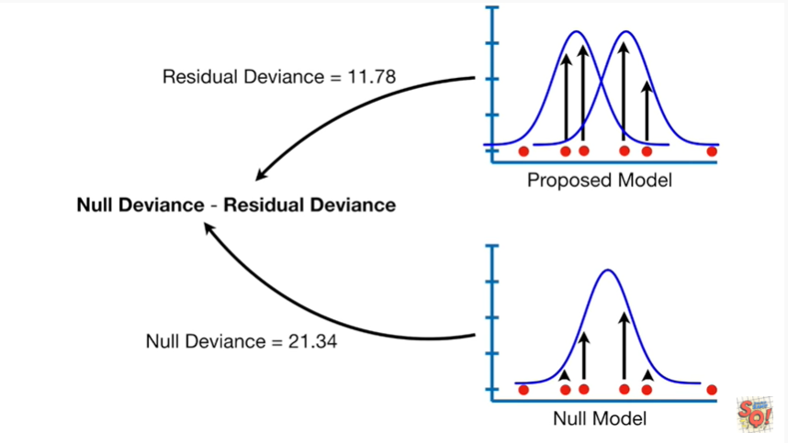

Oh baby baby baby boo boo boo boo

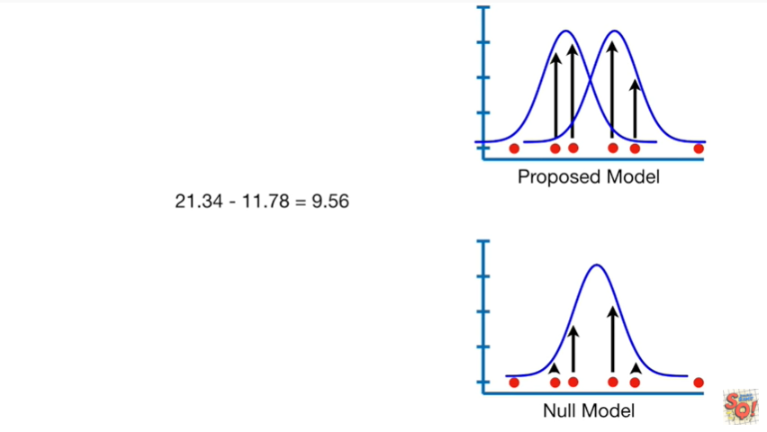

nine point five six.

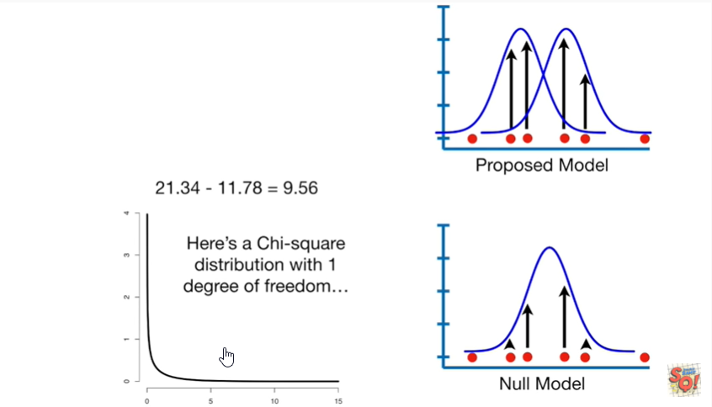

Here's a chi-square distribution with one degree of freedom.

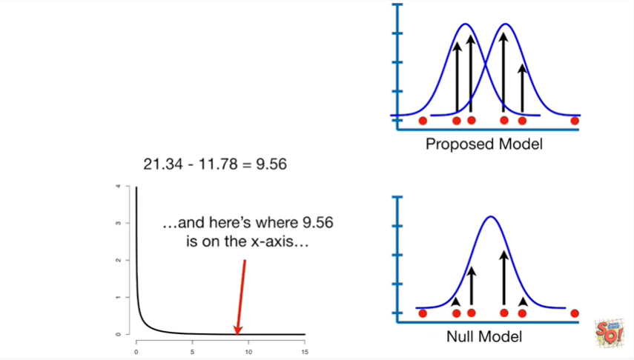

and here's where nine point five six is on the x-axis

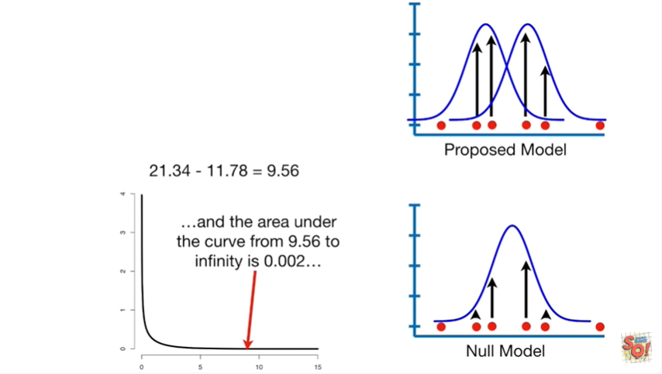

and the area under the curve from nine point five six to infinity is zero point zero zero two.

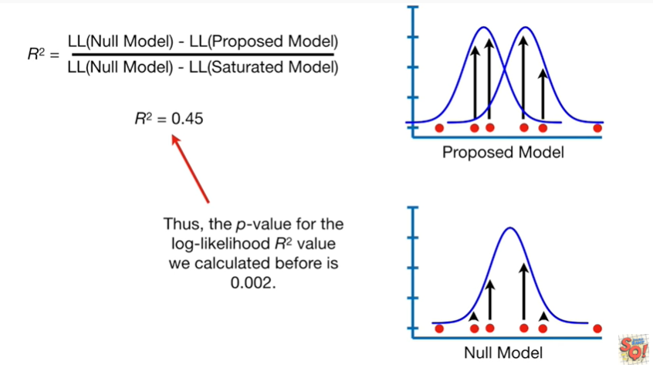

Thus the p-value for the log-likelihood r-squared value we calculated before is zero point zero zero two.

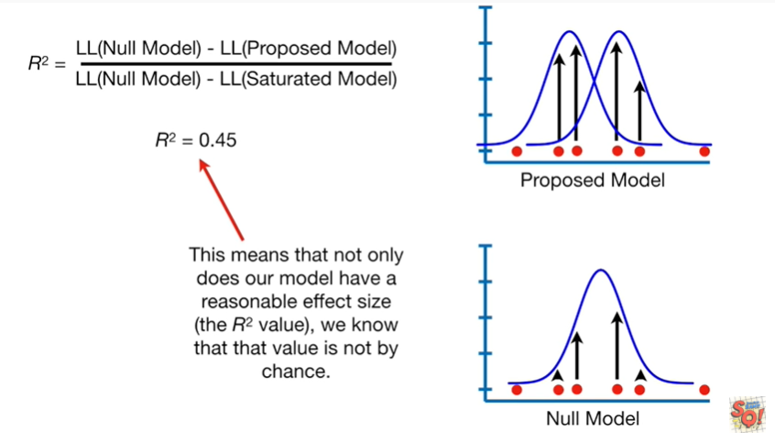

This means that not only does our model have a reasonable effect size the r-squared value, we know that that value is not by chance.

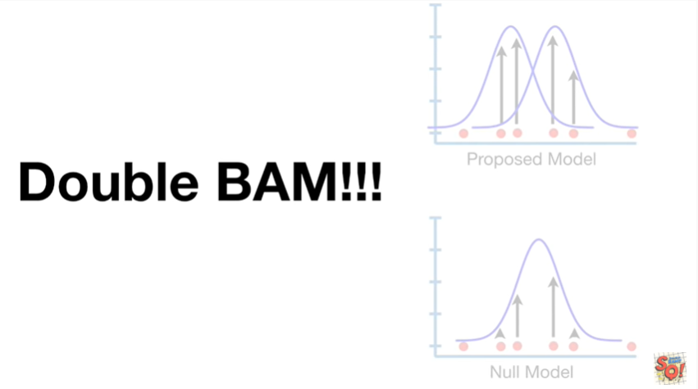

Double bam !!!

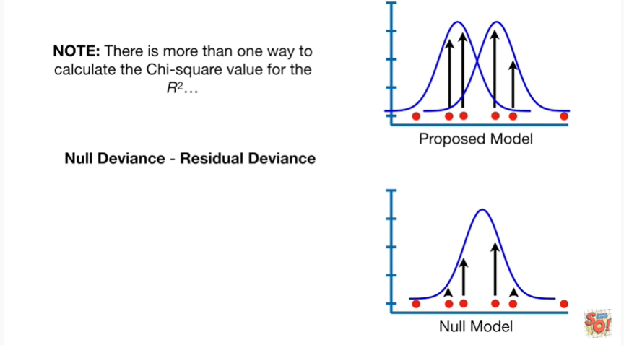

Note : there is more than one way to calculate the chi-squared value for the r-squared.

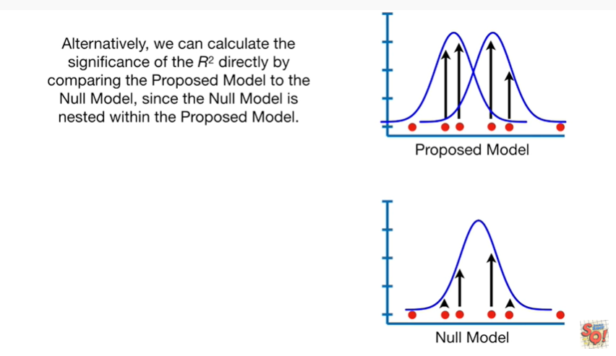

Alternatively we can calculate the significance of the r-squared directly by comparing the proposed model to the null model, since the null model is nested within the proposed model.

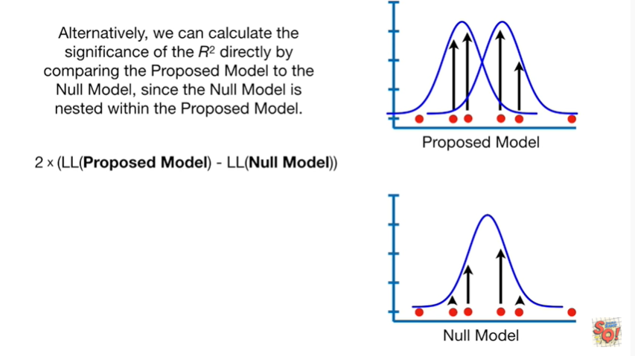

The formula is simply two times the difference between the log-likelihood of the proposed model and the log-likelihood of the null model.

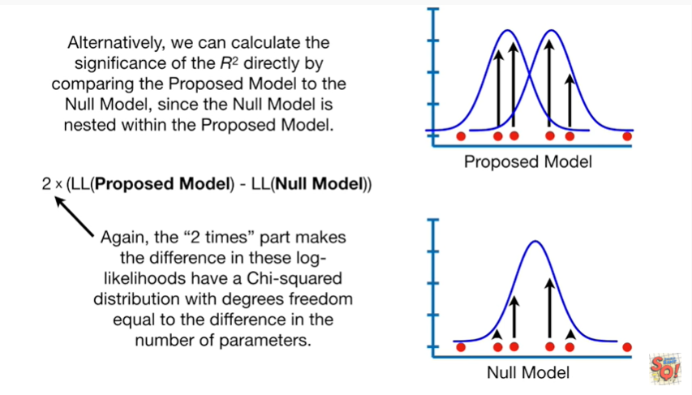

Again the two times part makes the difference in these log likelihoods have a chi-squared distribution with degrees freedom equal to the difference in the number of parameters.

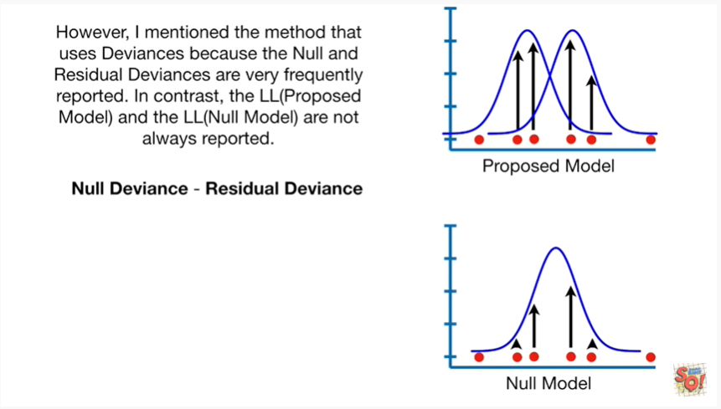

However I mentioned the method that uses deviances because the null and residual deviances are very frequently reported.

In contrast the log-likelihood of the proposed model and the log-likelihood of the null model are not always reported.



Little BAM !



Okay we talked about the saturated model, residual deviance and null deviance.

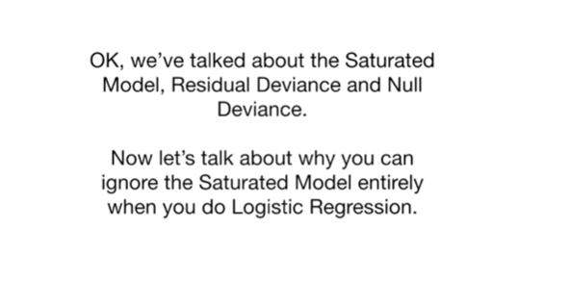

Now let's talk about why you can ignore the saturated model entirely when you do logistic regression.

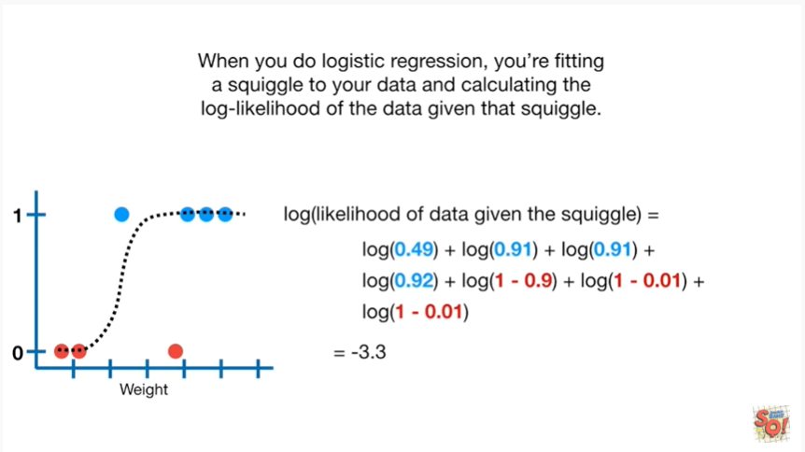

When you do logistic regression you're fitting a squiggle to your data and calculating the log likelihood of the data given that squiggle.

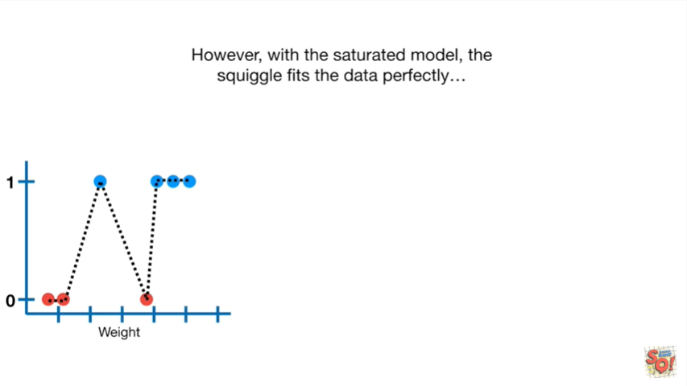

However with the saturated model the squiggle fits the data perfectly.

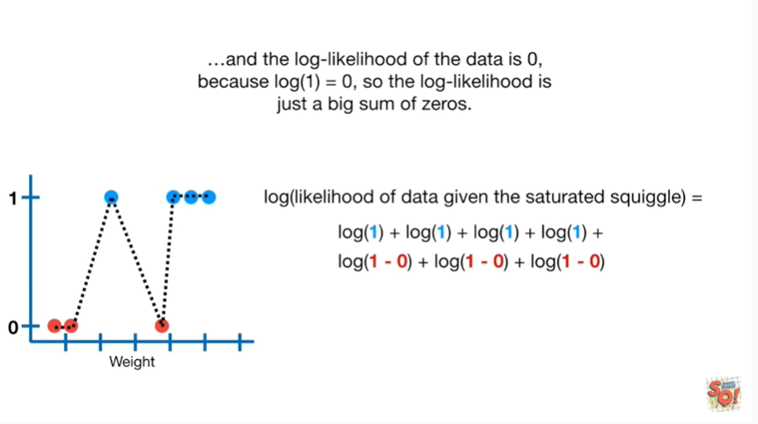

because the log of one equals zero

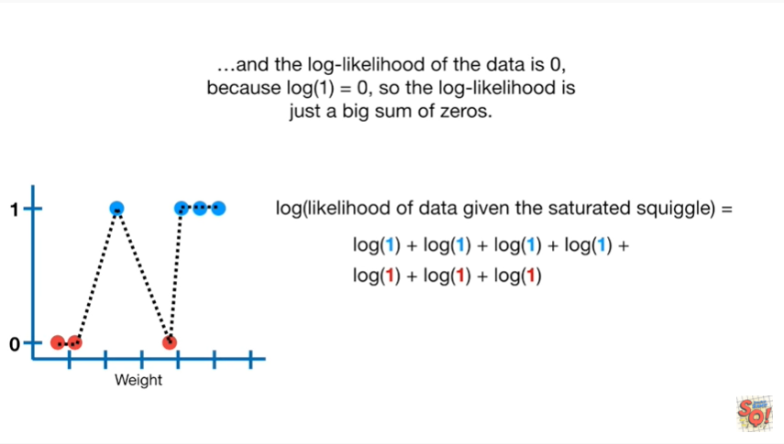

And the log likelihood of the data is zero

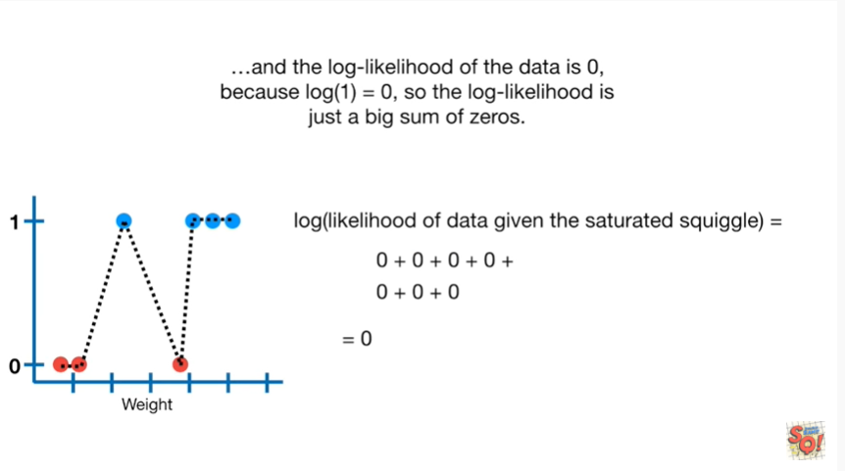

So the log likelihood is just a big sum of zeroes.

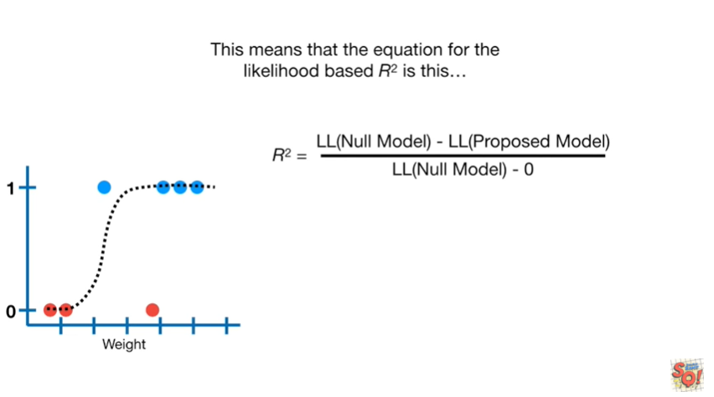

This means that the equation for the likelihood based R squared is this.

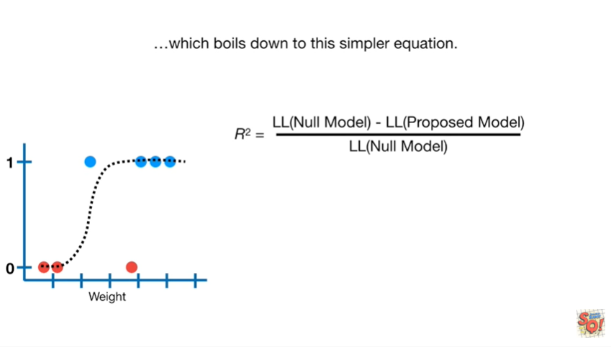

Which boils down to this simpler equation.

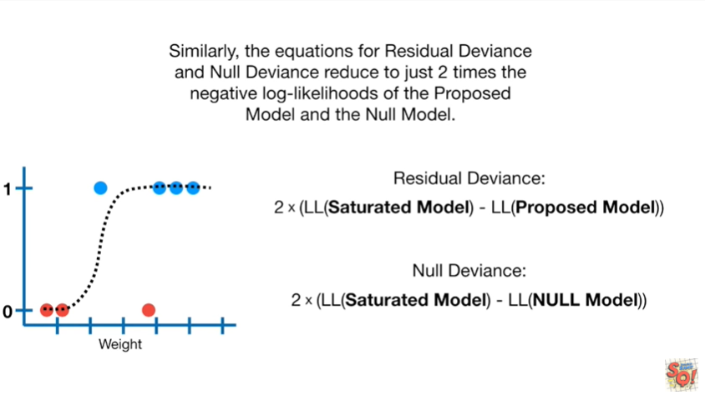

Similarly the equations for residual deviance and null deviance reduced to just two times the negative log likelihoods of the proposed model and the null model.

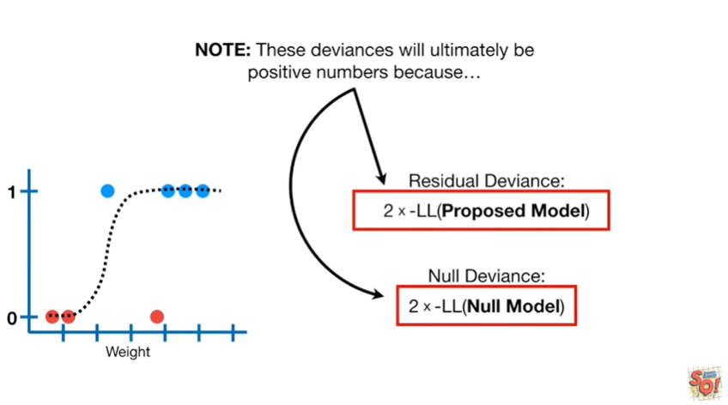

Note : these deviances will ultimately be positive numbers because

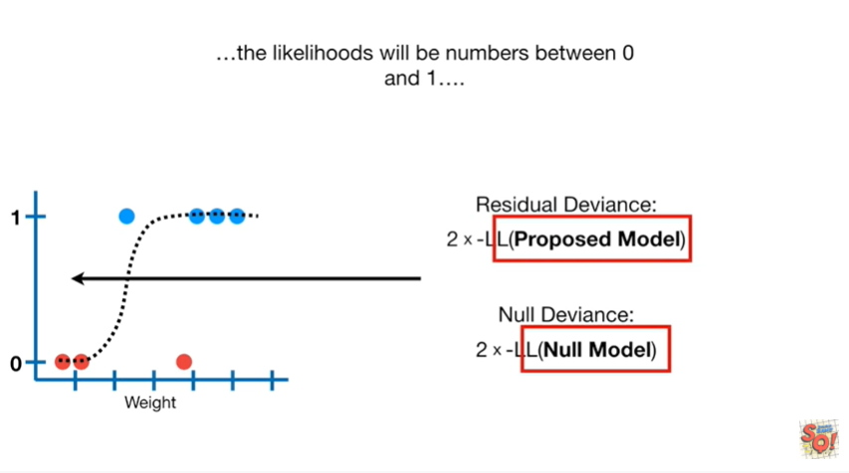

the likelihoods will be numbers between 0 & 1

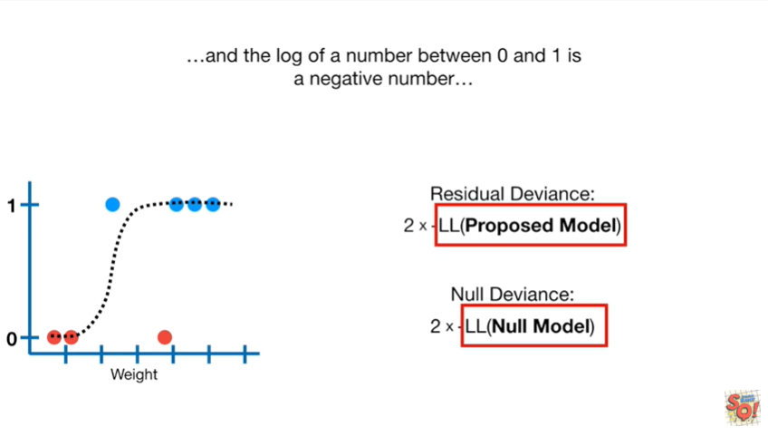

and the log of a number between 0 & 1 is a negative number

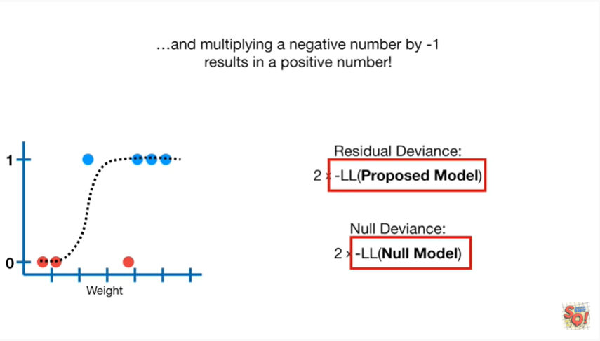

and multiplying a negative number by negative 1 results in a positive number.

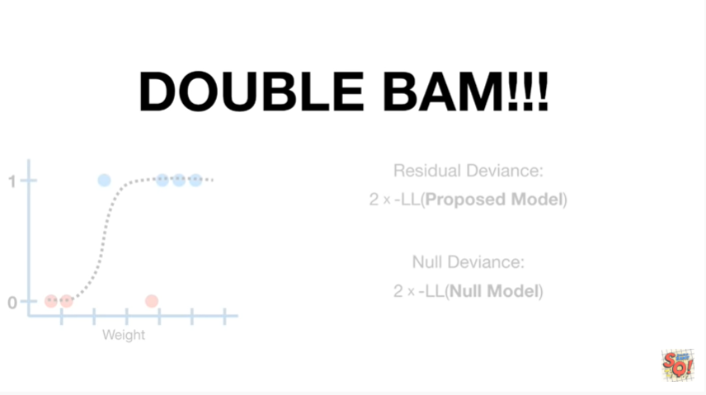

Double BAM !!!



In summary

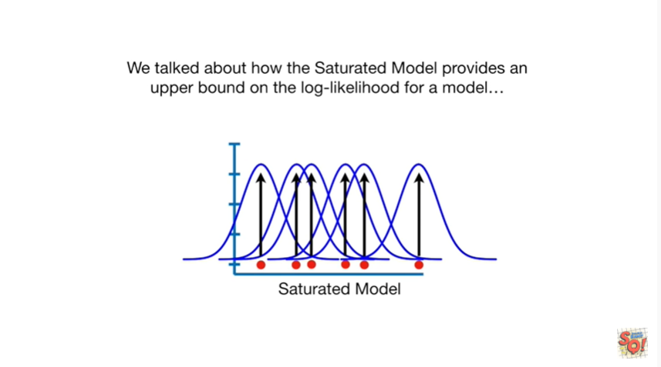

we talked about how the saturated model provides an upper bound on the log-likelihood for a model

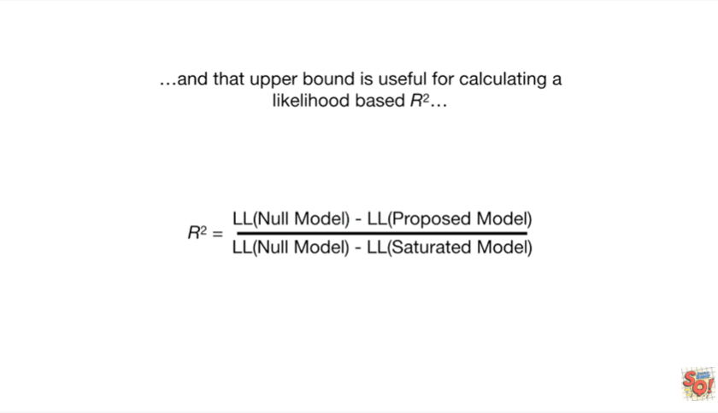

and that upper bound is useful for calculating a likelihood based r-squared.

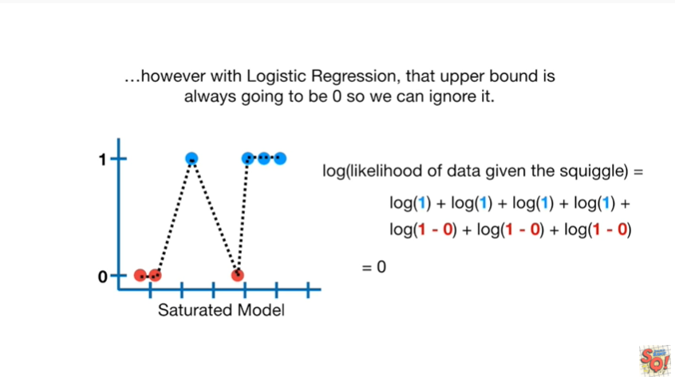

However with logistic regression the upper bound is always going to be zero, so we can ignore it.

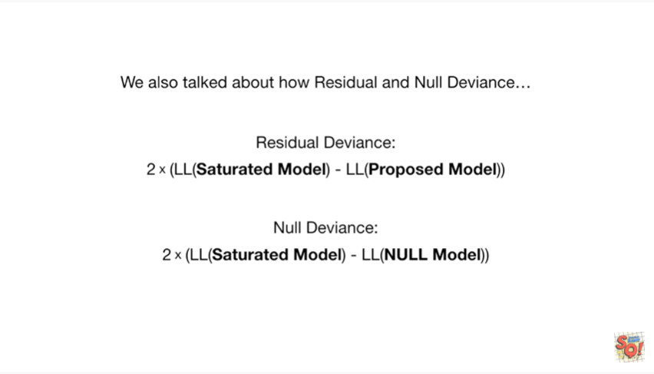

We also talked about how residual and null deviance can be used to calculate the p-value for a likelihood based r-squared.

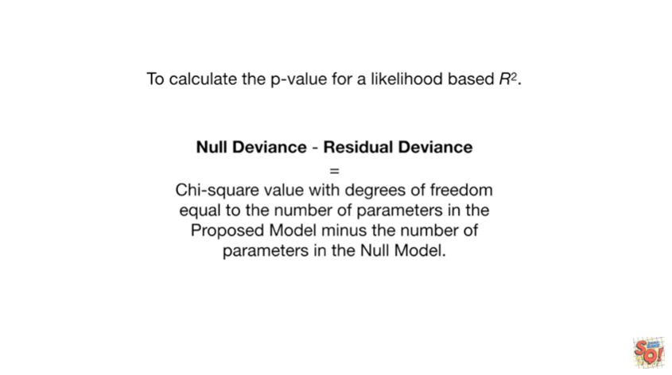

The difference between the null deviance and the residual deviance equals a chi-squared value with degrees of freedom equal to the number of parameters in the proposed model minus the number of parameters in the null model.